**Team 10**

**Ashish Shinde (NUID: 002199940)**

**Disha Vaswani (NUID: 002199940)**

**Question 2:**

**2. Load Big Query tables in a dataset in your project folder (1/1/2014-12/31/2020 (NOT 2021))**

**Trends and Analysis:**

Analysis:

Gender Analysis: Any trends from 2014 to 2020 regarding above

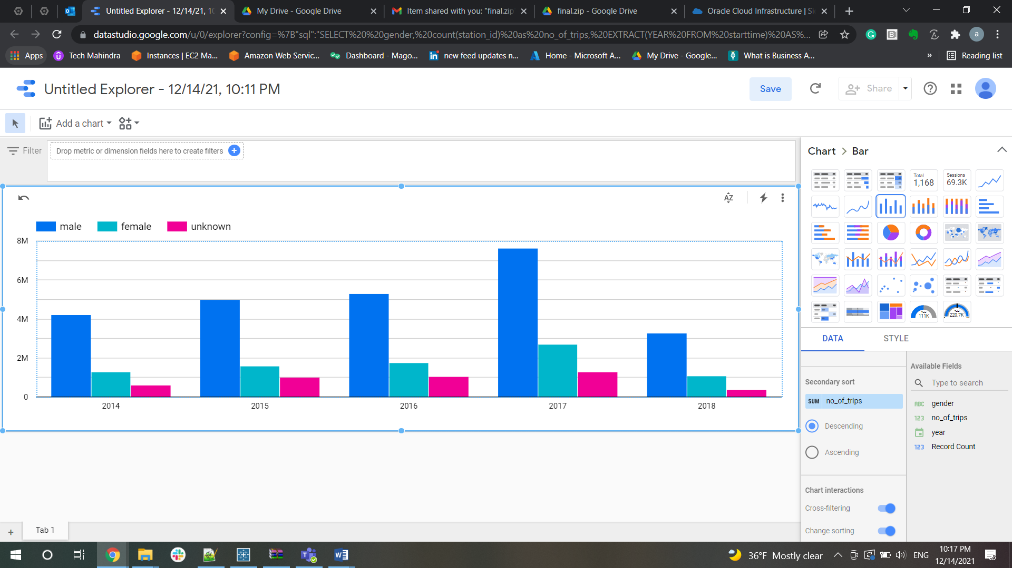

**Citi bikes have more male users than female users**

 User Analysis -- Subscriber versus customer grouped together query

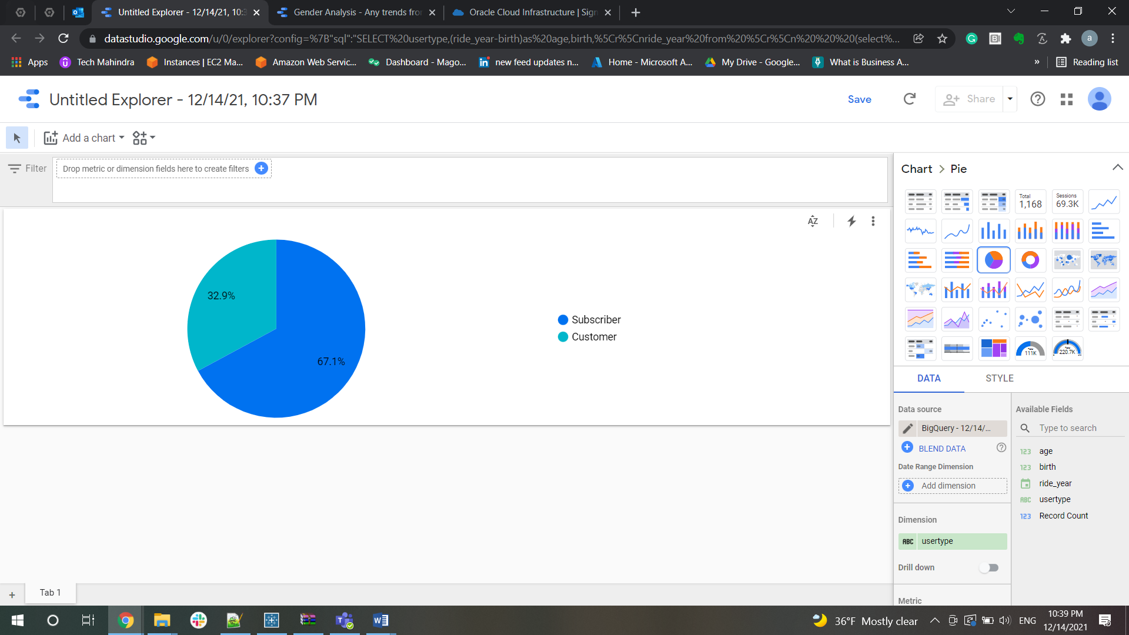

**Number of Subscribers are more than the customers**

How many bike trips and what is the trend over time

-- How many bike trips and what is the trend over time

-- calendar year (2017)

SELECT count(*) as number_of_trips, EXTRACT(YEAR FROM starttime) AS year, EXTRACT(MONTH  FROM starttime) AS MONTH  from `steady-anagram-329601.dmdd_final.citibike_trips`

group by year, MONTH

having year = 2019;

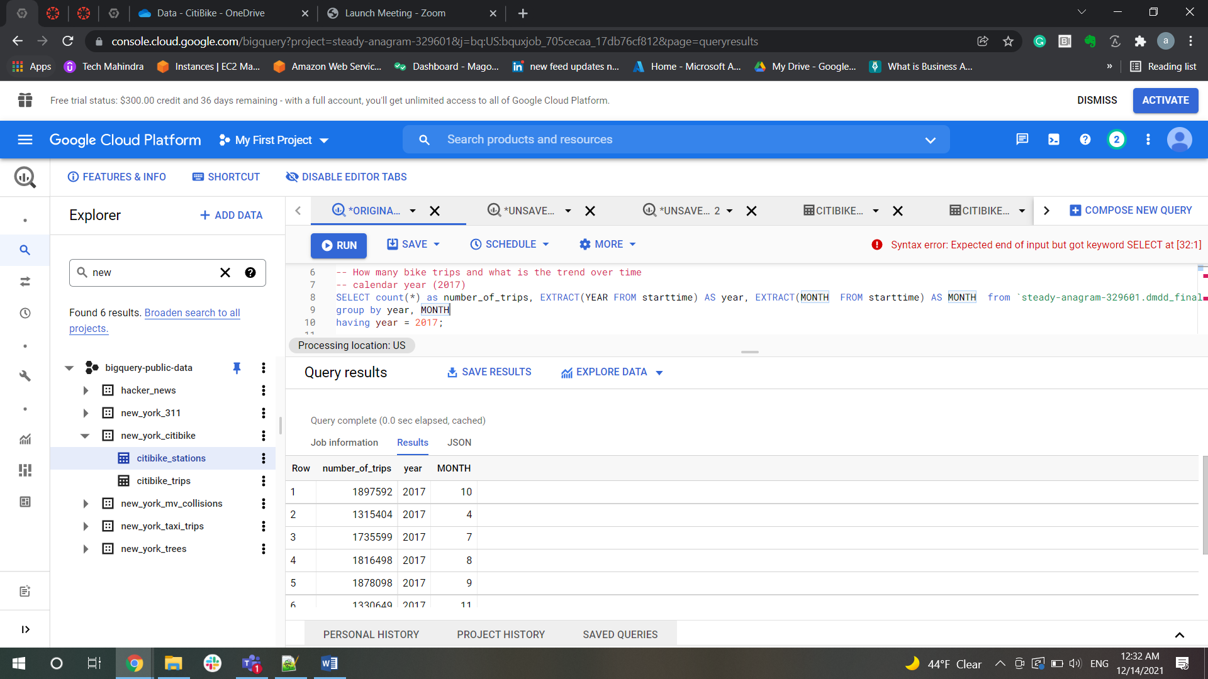

-- calendar month & year (2017-09)

SELECT count(*) as number_of_trips, EXTRACT(YEAR FROM starttime) AS year,

EXTRACT(MONTH FROM starttime) AS MONTH,EXTRACT(WEEK FROM starttime) AS WEEK from `steady-anagram-329601.dmdd_final.citibike_trips`

group by year, MONTH,WEEK

having (year = 2017 and MONTH=9);

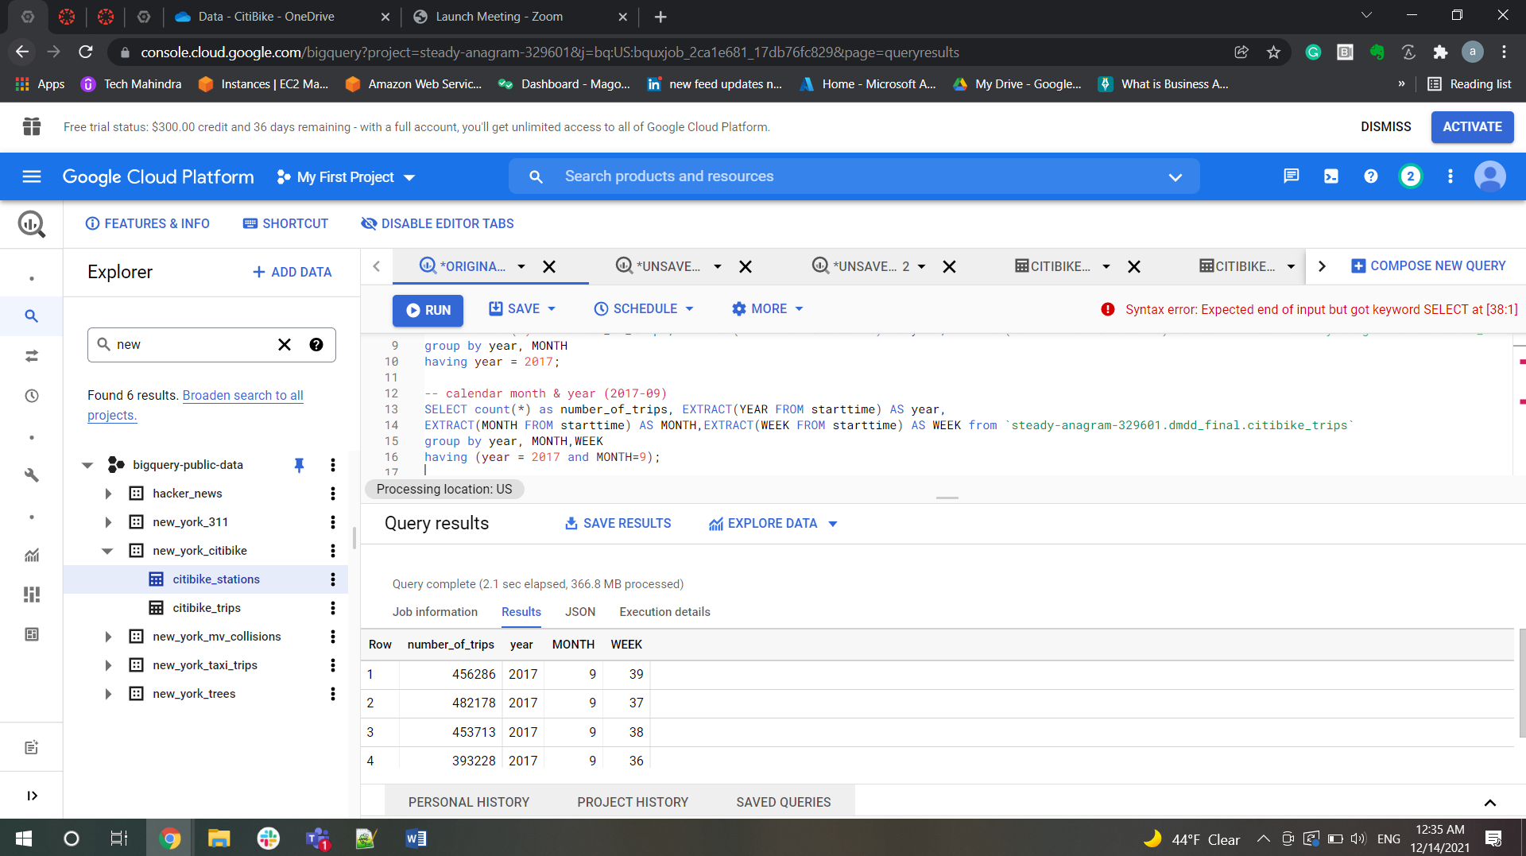

-- calendar week (2017-36)

SELECT count(*) as number_of_trips, EXTRACT(YEAR FROM starttime) AS year,

EXTRACT(MONTH FROM starttime) AS MONTH,EXTRACT(WEEK FROM starttime) AS WEEK, EXTRACT(DAY FROM starttime) AS DAY from `steady-anagram-329601.dmdd_final.citibike_trips`

group by year, MONTH,WEEK,DAY

having (year = 2017 and MONTH=9 and WEEK=36);

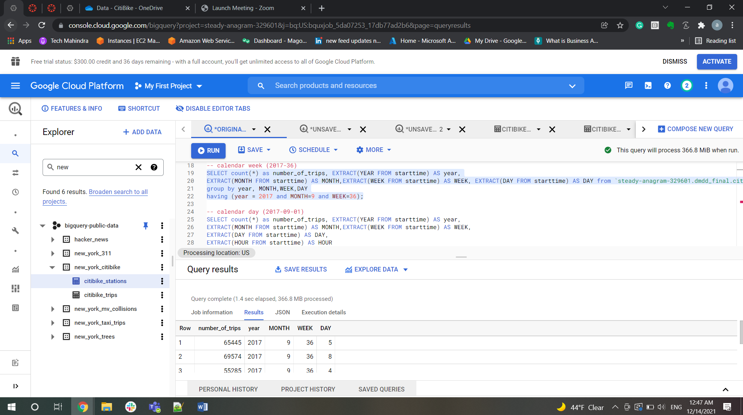

-- calendar day (2017-09-01)

SELECT count(*) as number_of_trips, EXTRACT(YEAR FROM starttime) AS year,

EXTRACT(MONTH FROM starttime) AS MONTH,EXTRACT(WEEK FROM starttime) AS WEEK,

EXTRACT(DAY FROM starttime) AS DAY,

EXTRACT(HOUR FROM starttime) AS HOUR

from `steady-anagram-329601.dmdd_final.citibike_trips`

group by year, MONTH,WEEK,DAY,HOUR

having (year = 2017 and MONTH=9 AND DAY=1);

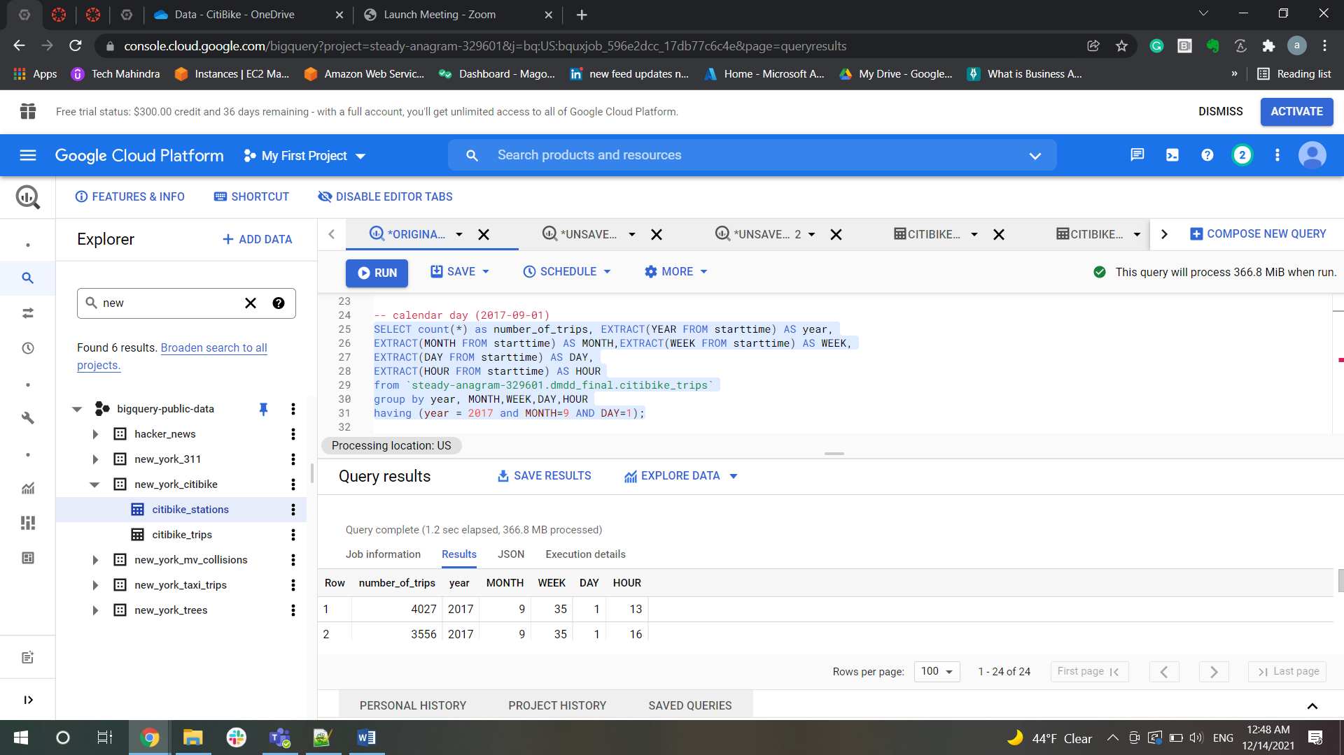

Average number of bike trips and may also want to compare YOY (year over year) changes

-- Average number of bike trips and may also want to compare YOY (year over year) changes

-- per day, i.e., Sunday, Monday,...Saturday

   SELECT EXTRACT(YEAR from starttime) as year,

   EXTRACT(DAY from starttime) as DAY,EXTRACT(DAYOFWEEK from starttime) AS Day_of_week,

   avg(trips.countt) as avgtrip FROM (select count(*) as countt from `steady-anagram-329601.dmdd_final.citibike_trips`)as trips

   cross join `steady-anagram-329601.dmdd_final.citibike_trips`

   group BY year,day, Day_of_week;

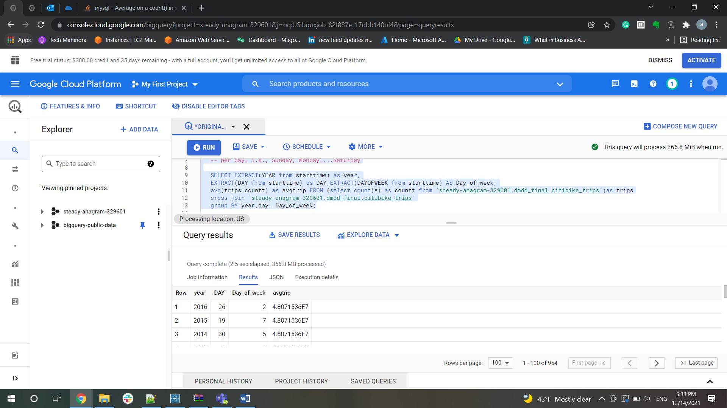

   -- weekday versus weekend

 SELECT EXTRACT(YEAR from starttime) as year,

EXTRACT(DAY from starttime) as DAY,

CASE

WHEN EXTRACT(DAYOFWEEK from starttime) IN (6,7) THEN 'Weekend'

ELSE 'Weekday'

END AS columnnn,

avg(trips.countt) as avgtrip FROM (select count(*) as countt from `steady-anagram-329601.dmdd_final.citibike_trips`)as trips

cross join `steady-anagram-329601.dmdd_final.citibike_trips`

group BY year,day,columnnn;

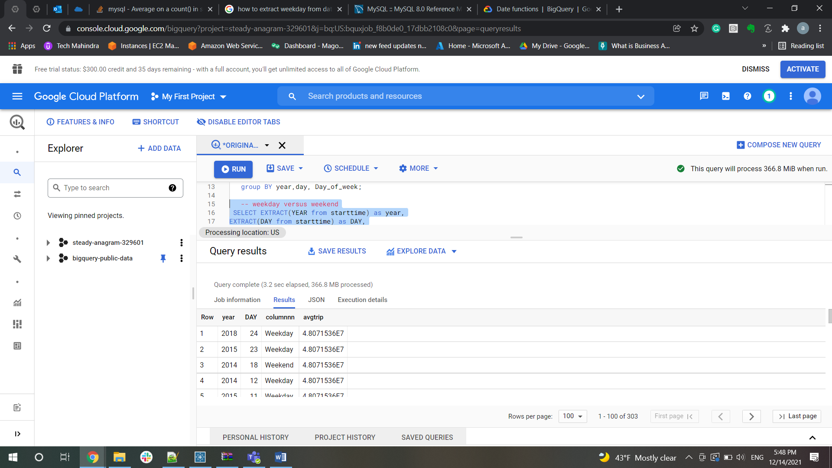

--month

SELECT EXTRACT(YEAR from starttime) as year,

EXTRACT(MONTH from starttime) as MONTH,

avg(trips.countt) as avgtrip FROM (select count(*) as countt from `steady-anagram-329601.dmdd_final.citibike_trips`)as trips

cross join `steady-anagram-329601.dmdd_final.citibike_trips`

group BY year,MONTH;

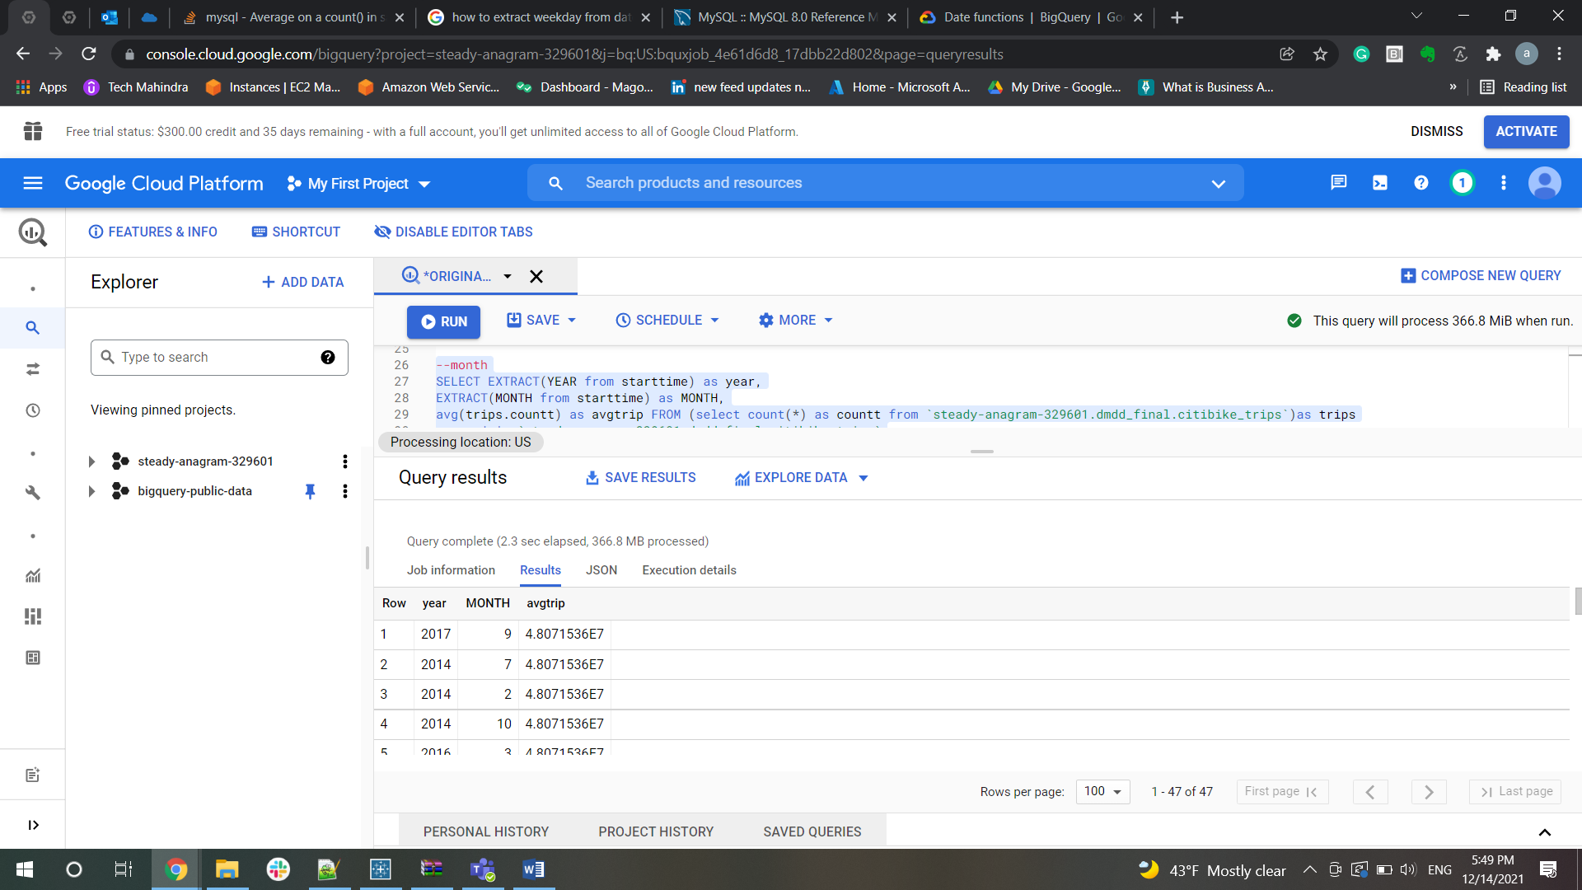

--calendar week

SELECT EXTRACT(YEAR from starttime) as year,

EXTRACT(MONTH from starttime) as MONTH,

avg(trips.countt) as avgtrip FROM (select count(*) as countt from `steady-anagram-329601.dmdd_final.citibike_trips`)as trips

cross join `steady-anagram-329601.dmdd_final.citibike_trips`

group BY year,MONTH;

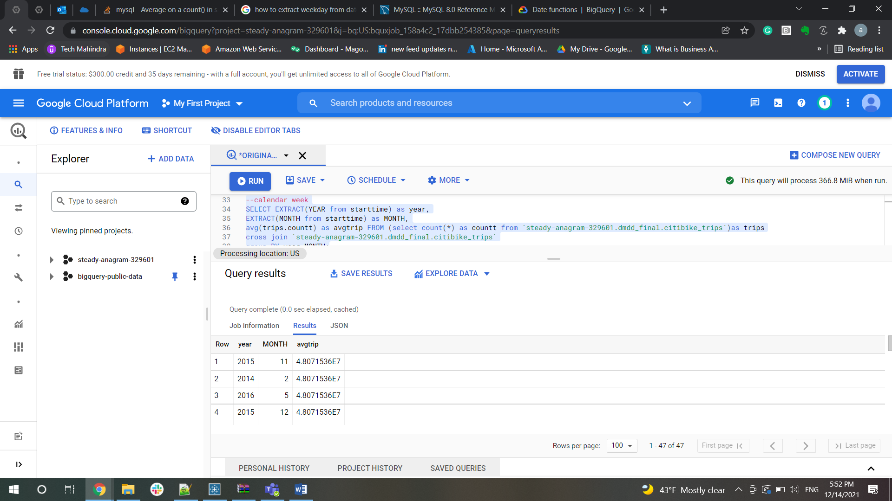

Examining when trips occur during the day

• Breakdown of subscriber (or member) vs customer (non-subscriber) rides

SELECT EXTRACT(HOUR from starttime) as hour, count(*) as biketrips, usertype

from `steady-anagram-329601.dmdd_final.citibike_trips`

group by hour, usertype

order by hour, usertype;

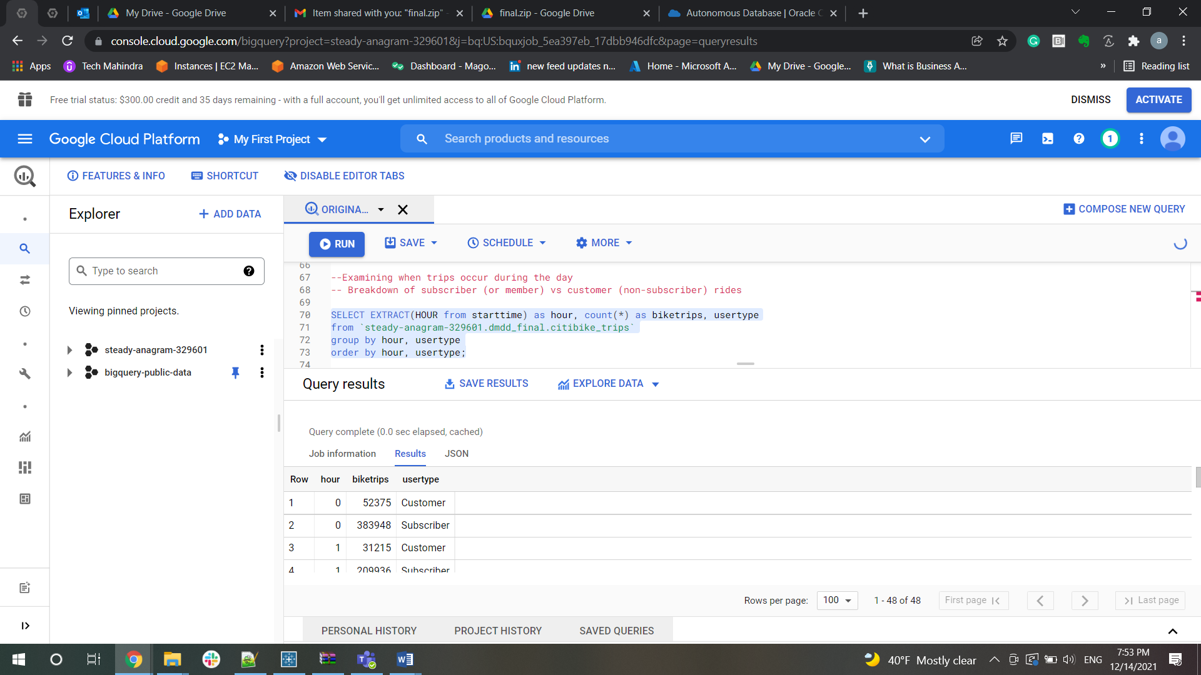

-- How many bike trips occur during what periods of the day:

-- By hour (0900, 1300)

SELECT EXTRACT(HOUR from starttime) as hour, count(*) as biketrips

from `steady-anagram-329601.dmdd_final.citibike_trips`

group by hour

order by hour;

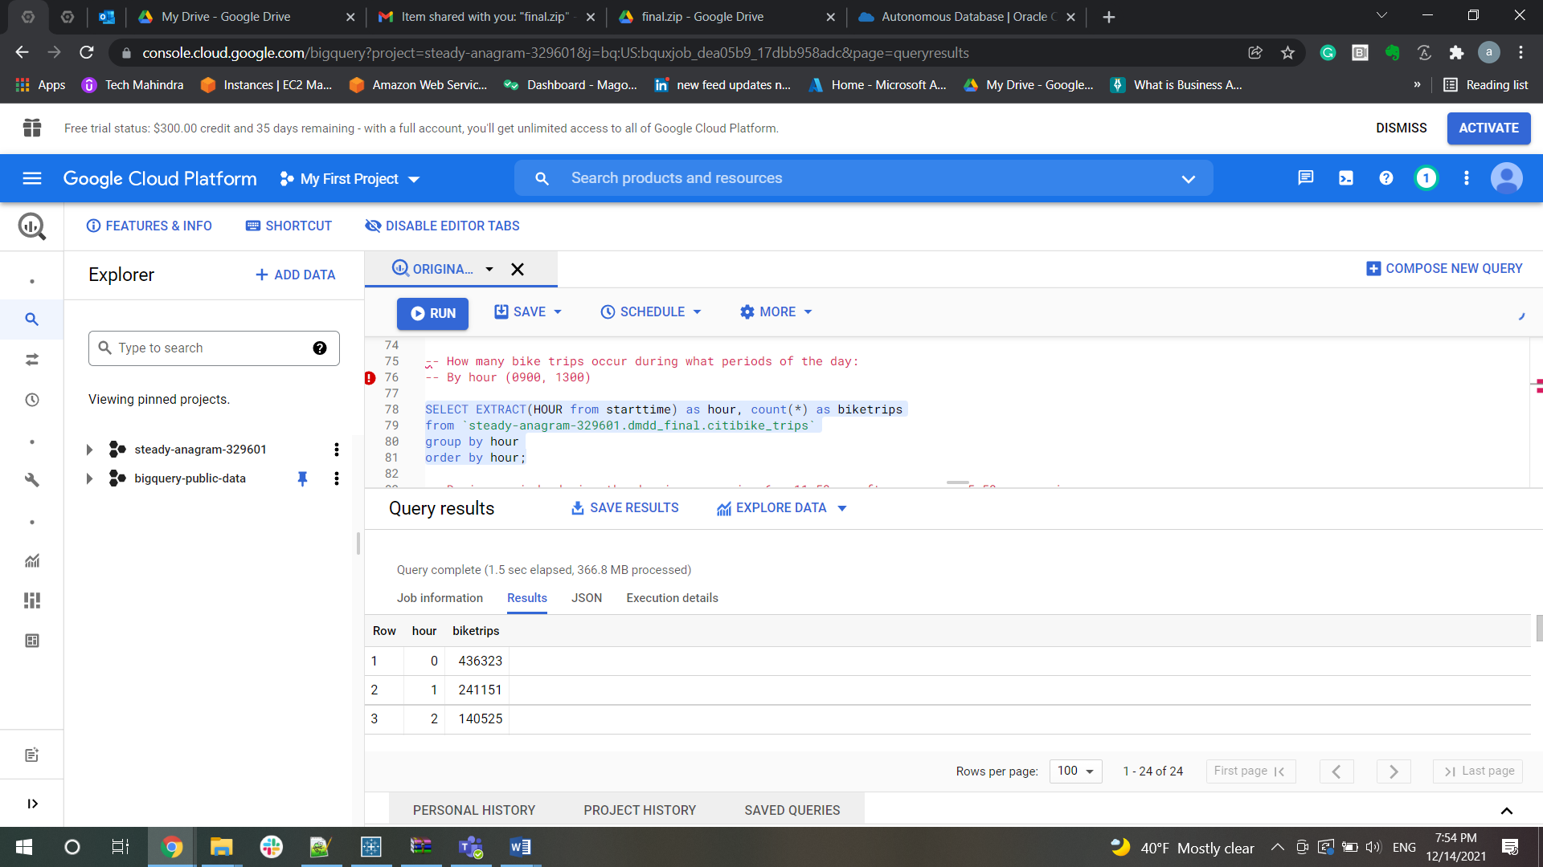

-- During periods during the day i.e., morning 6am-11:59am, afternoon noon-5:59pm, evening

--6pm-10pm

-- How many round trips (start and end station are the same) versus non-round

-- trips (different start and end station)

SELECT (select count(*) as common_trip from `steady-anagram-329601.dmdd_final.citibike_trips` where start_station_name = end_station_name) as round,

(select count(*) as diff_trip from `steady-anagram-329601.dmdd_final.citibike_trips` where start_station_name != end_station_name) as nonround

from `steady-anagram-329601.dmdd_final.citibike_trips` group by round,nonround;

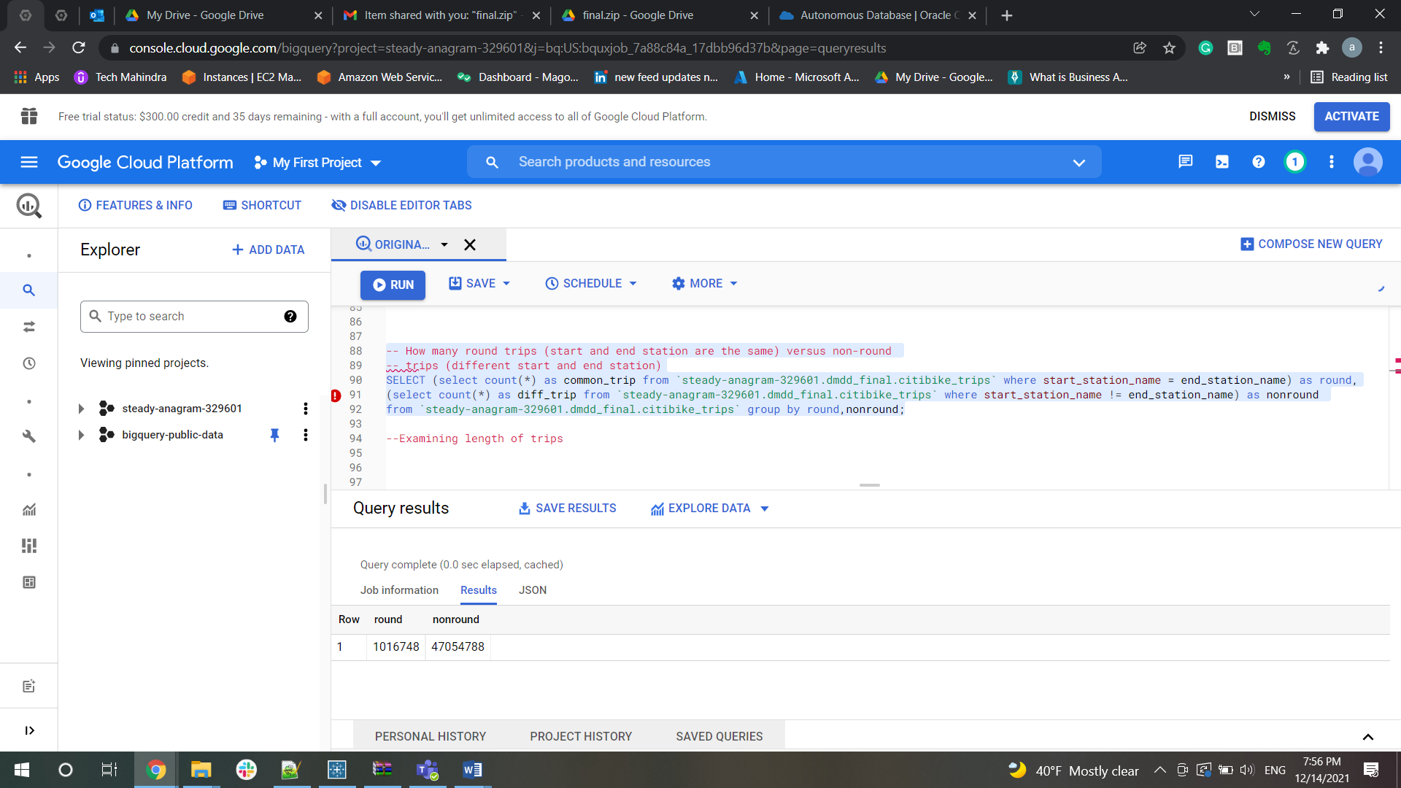

--Further breakdown subscriber vs customer

SELECT (select count(*) as common_trip from `steady-anagram-329601.dmdd_final.citibike_trips` where start_station_name = end_station_name) as round,

(select count(*) as diff_trip from `steady-anagram-329601.dmdd_final.citibike_trips` where start_station_name != end_station_name) as nonround , usertype

from `steady-anagram-329601.dmdd_final.citibike_trips` group by round,nonround, usertype;

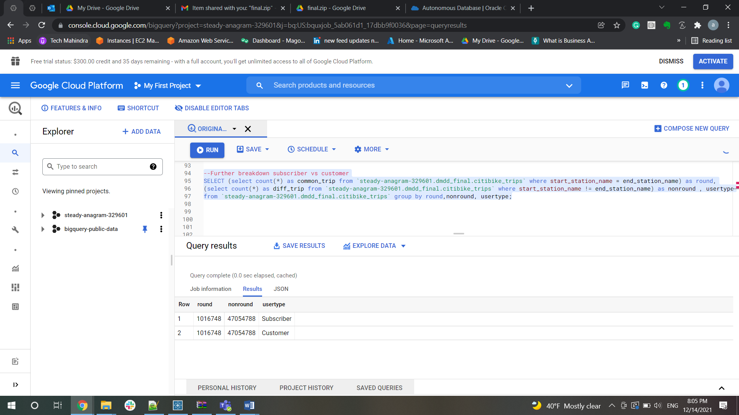

-- Average length of trip

SELECT (select count(*) as common_trip from `steady-anagram-329601.dmdd_final.citibike_trips` where start_station_name = end_station_name) as round,

(select count(*) as diff_trip from `steady-anagram-329601.dmdd_final.citibike_trips` where start_station_name != end_station_name) as nonround , usertype, avg(tripduration) as tripduration

from `steady-anagram-329601.dmdd_final.citibike_trips` group by round,nonround, usertype;

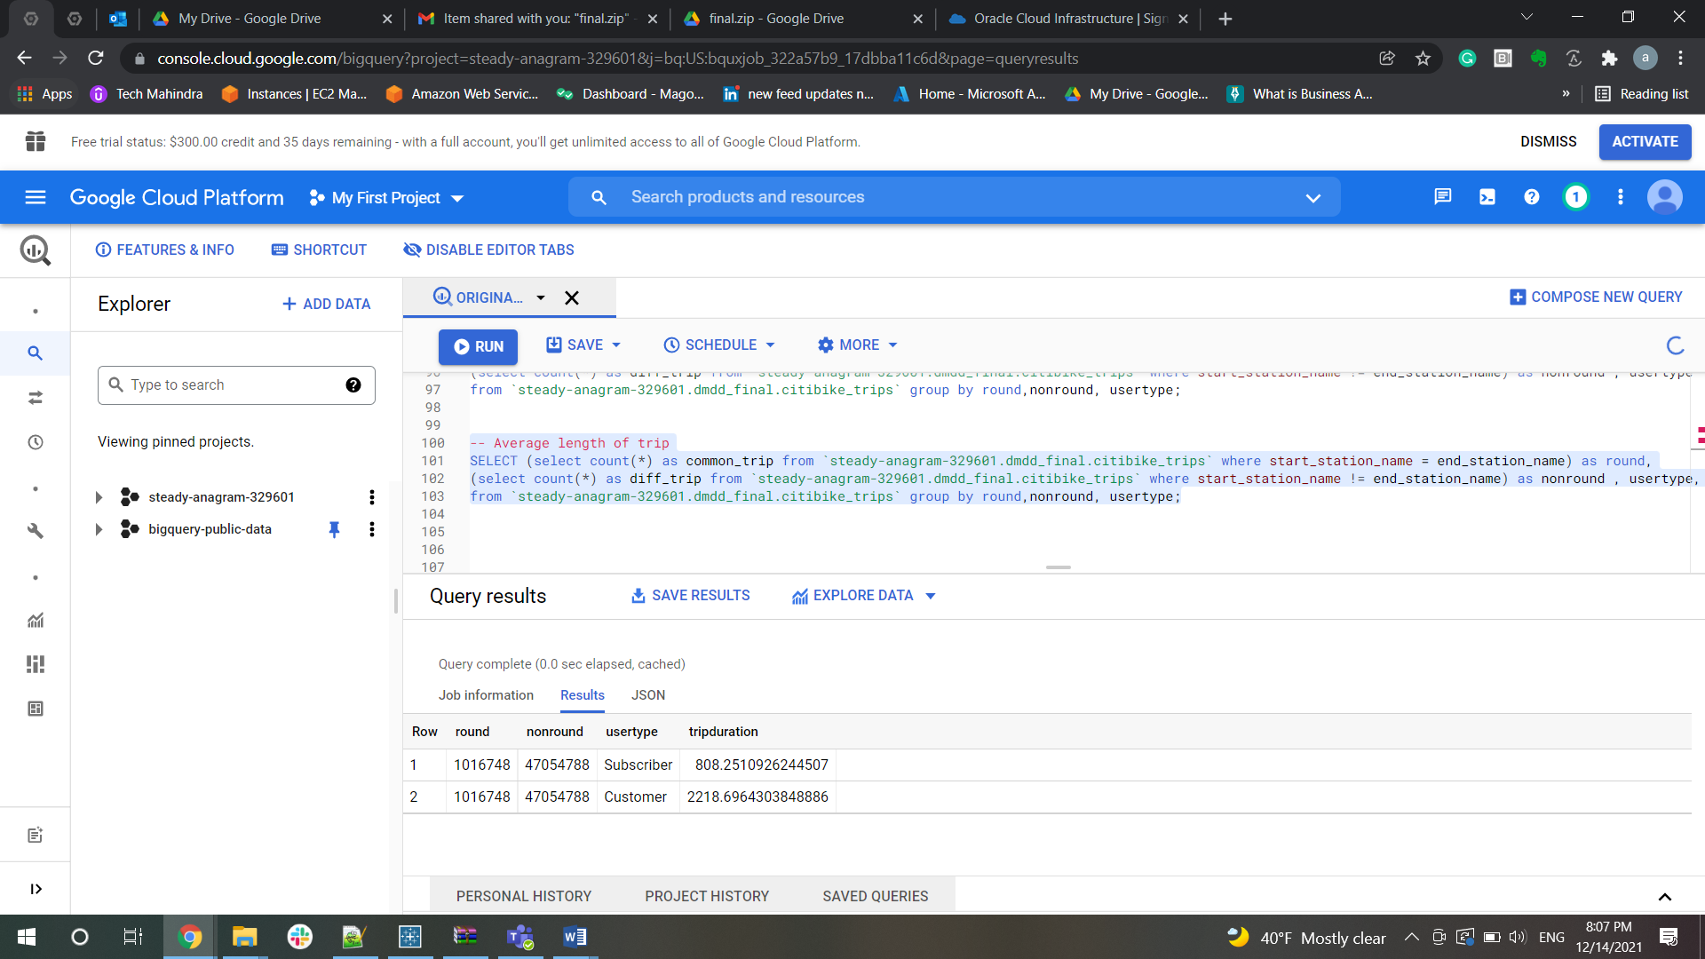

Examining length of trips

-- Length of trips (in time)\

-- What is the average length (in minutes) of bike trip?

SELECT avg(tripduration / 60) as Average_Trip FROM `steady-anagram-329601.dmdd_final.citibike_trips` ;

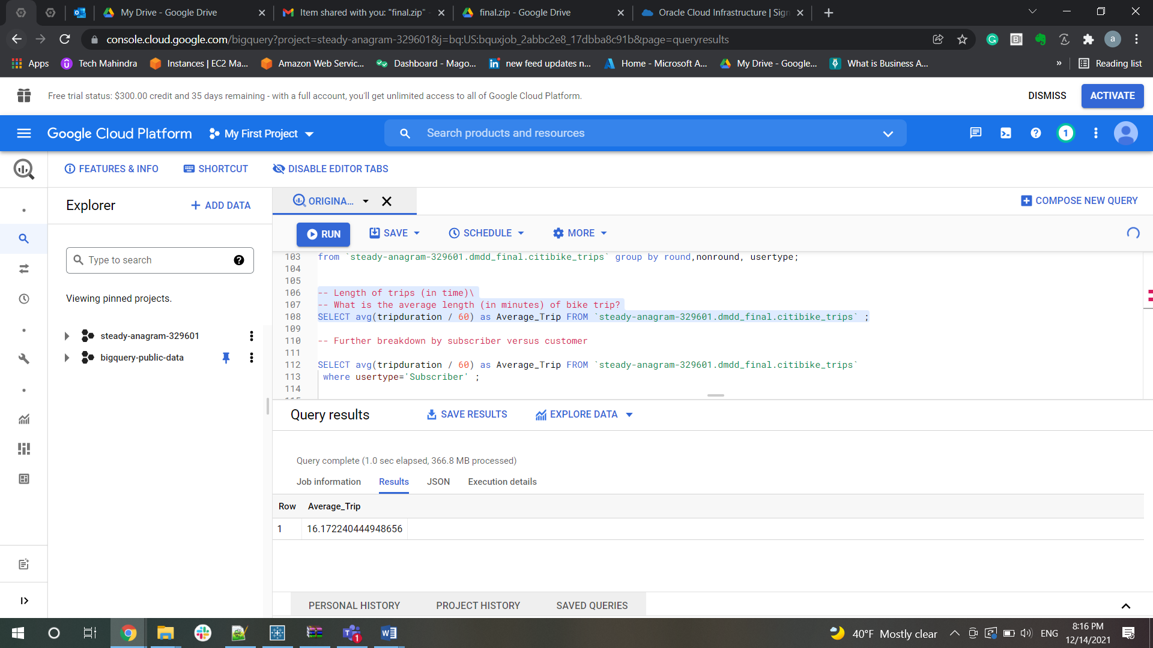

-- Further breakdown by subscriber versus customer

SELECT avg(tripduration / 60) as Average_Trip FROM `steady-anagram-329601.dmdd_final.citibike_trips`

 where usertype='Subscriber' ;

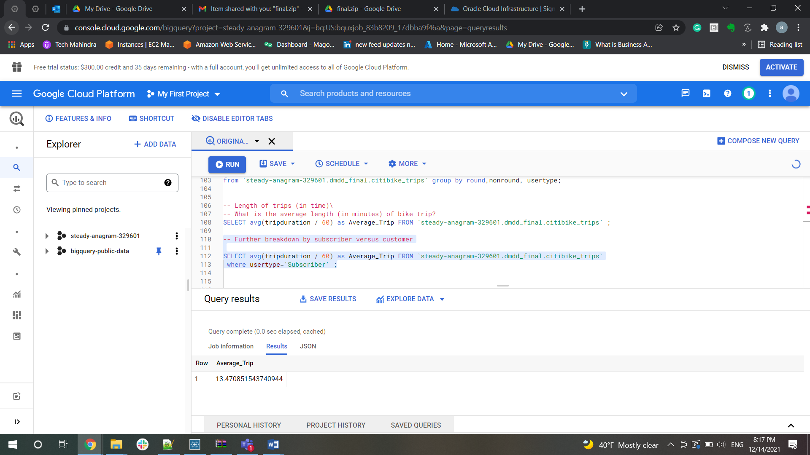

SELECT avg(tripduration / 60) as Average_Trip FROM `steady-anagram-329601.dmdd_final.citibike_trips`

where usertype='Customer' ;

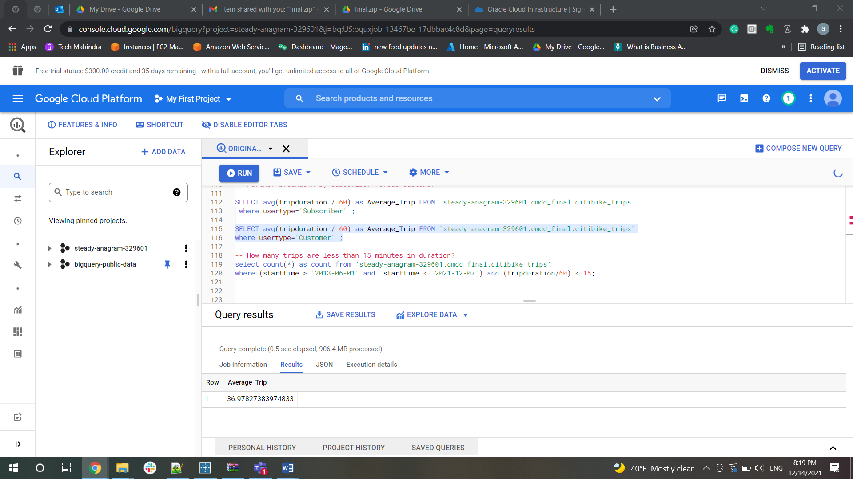

-- How many trips are less than 15 minutes in duration?

select count(*) as count from `steady-anagram-329601.dmdd_final.citibike_trips`

 where (tripduration/60) < 15;

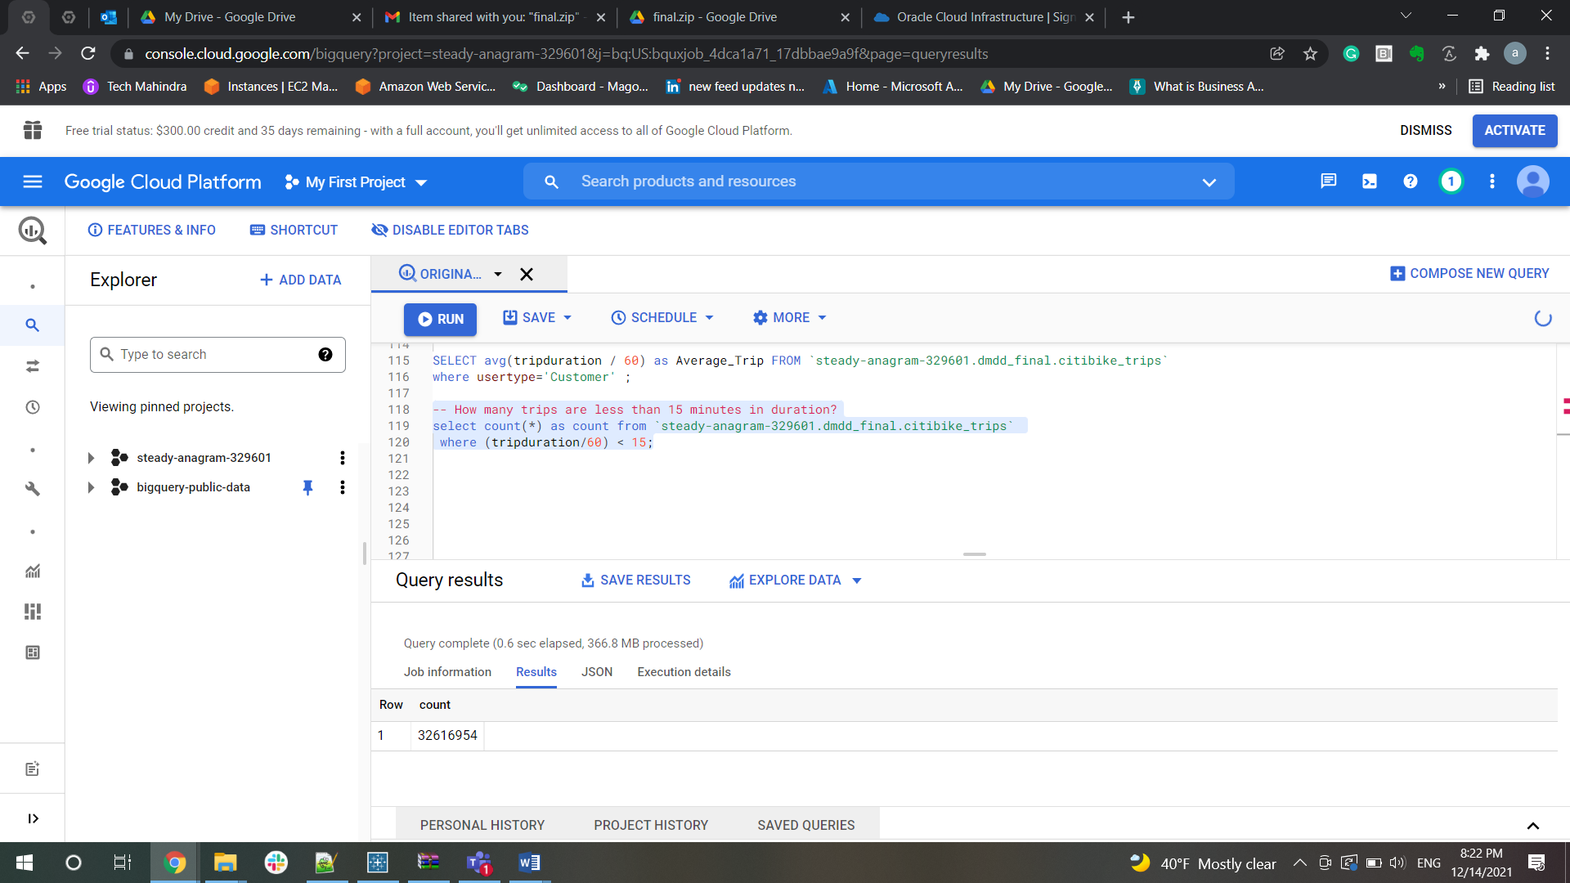

--How many trips are greater than 15 minutes but less than 1 hour in duration?

select count(*) as no_of_trips from `steady-anagram-329601.dmdd_final.citibike_trips`

where (tripduration/60) > 15 and (tripduration/60) < 60

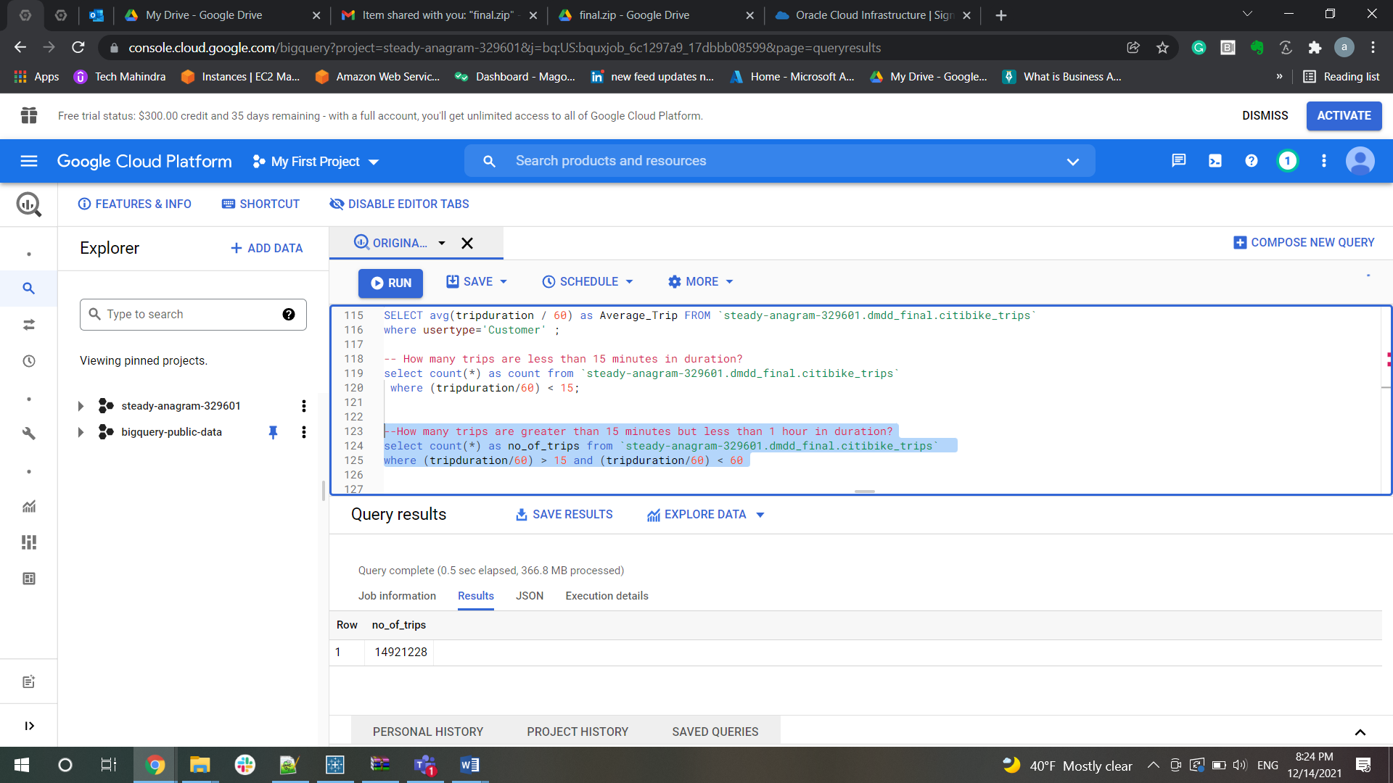

--How many trips are greater than 1 hour in duration?

SELECT count(*) as no_of_trips FROM `bigquery-public-data.new_york_citibike.citibike_trips`

where (tripduration / 60) > 60 ;

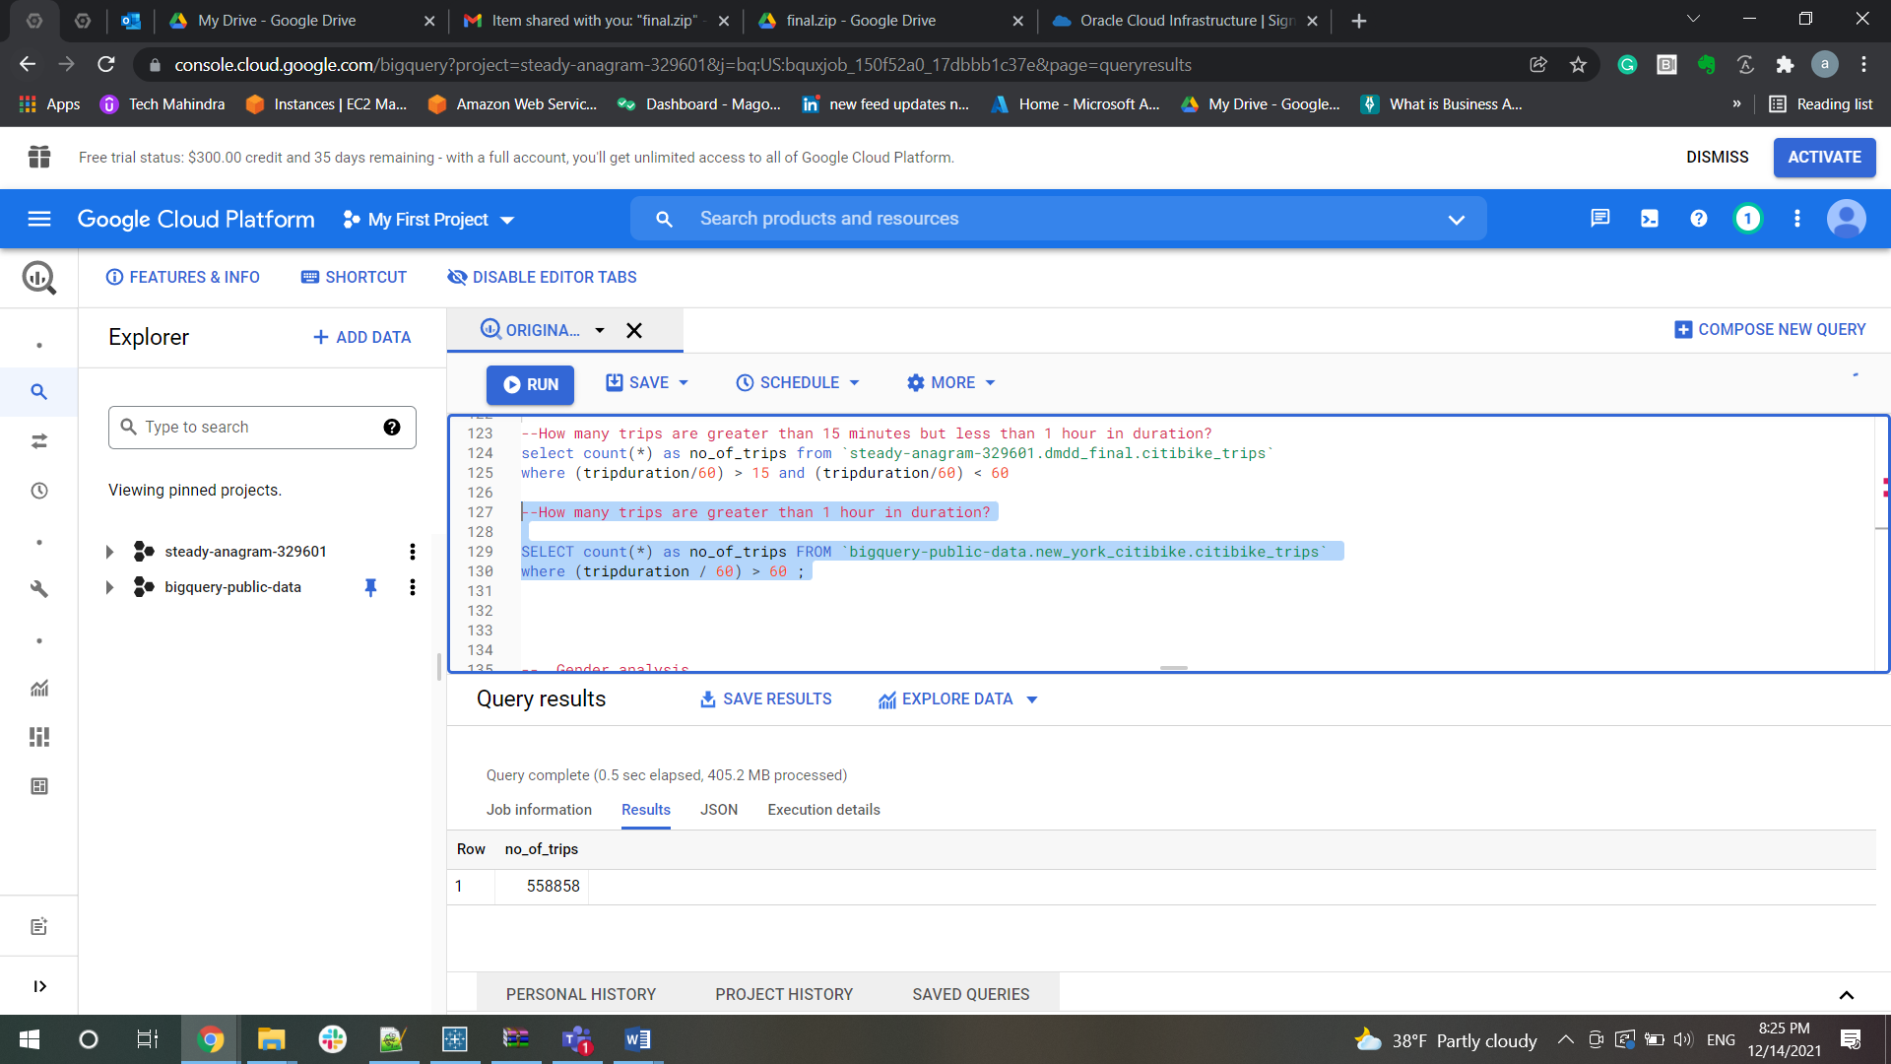

-- Most popular stations

-- What are the top 10 bike stations based on bike trips?

-- For staring a trip

SELECT start_station_id,start_station_name, count(station_id) as no_of_trips FROM `steady-anagram-329601.dmdd_final.citibike_trips`

inner join `steady-anagram-329601.dmdd_final.citibike_stations`

on Station_id = start_station_id

group by start_station_id, start_station_name

order by count(start_station_id) desc

limit 10;

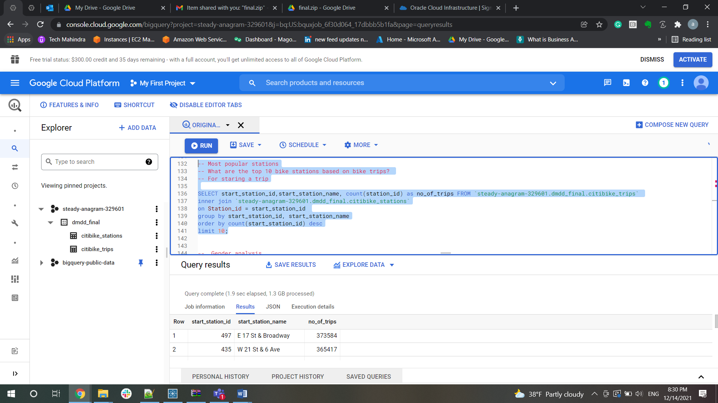

 --As a trip destination

SELECT end_station_id, end_station_name, count(end_station_id) as no_of_trips FROM `steady-anagram-329601.dmdd_final.citibike_trips`

inner join `steady-anagram-329601.dmdd_final.citibike_stations`

on Station_id = end_station_id

group by end_station_id, end_station_name

order by count(end_station_id) desc

limit 10;

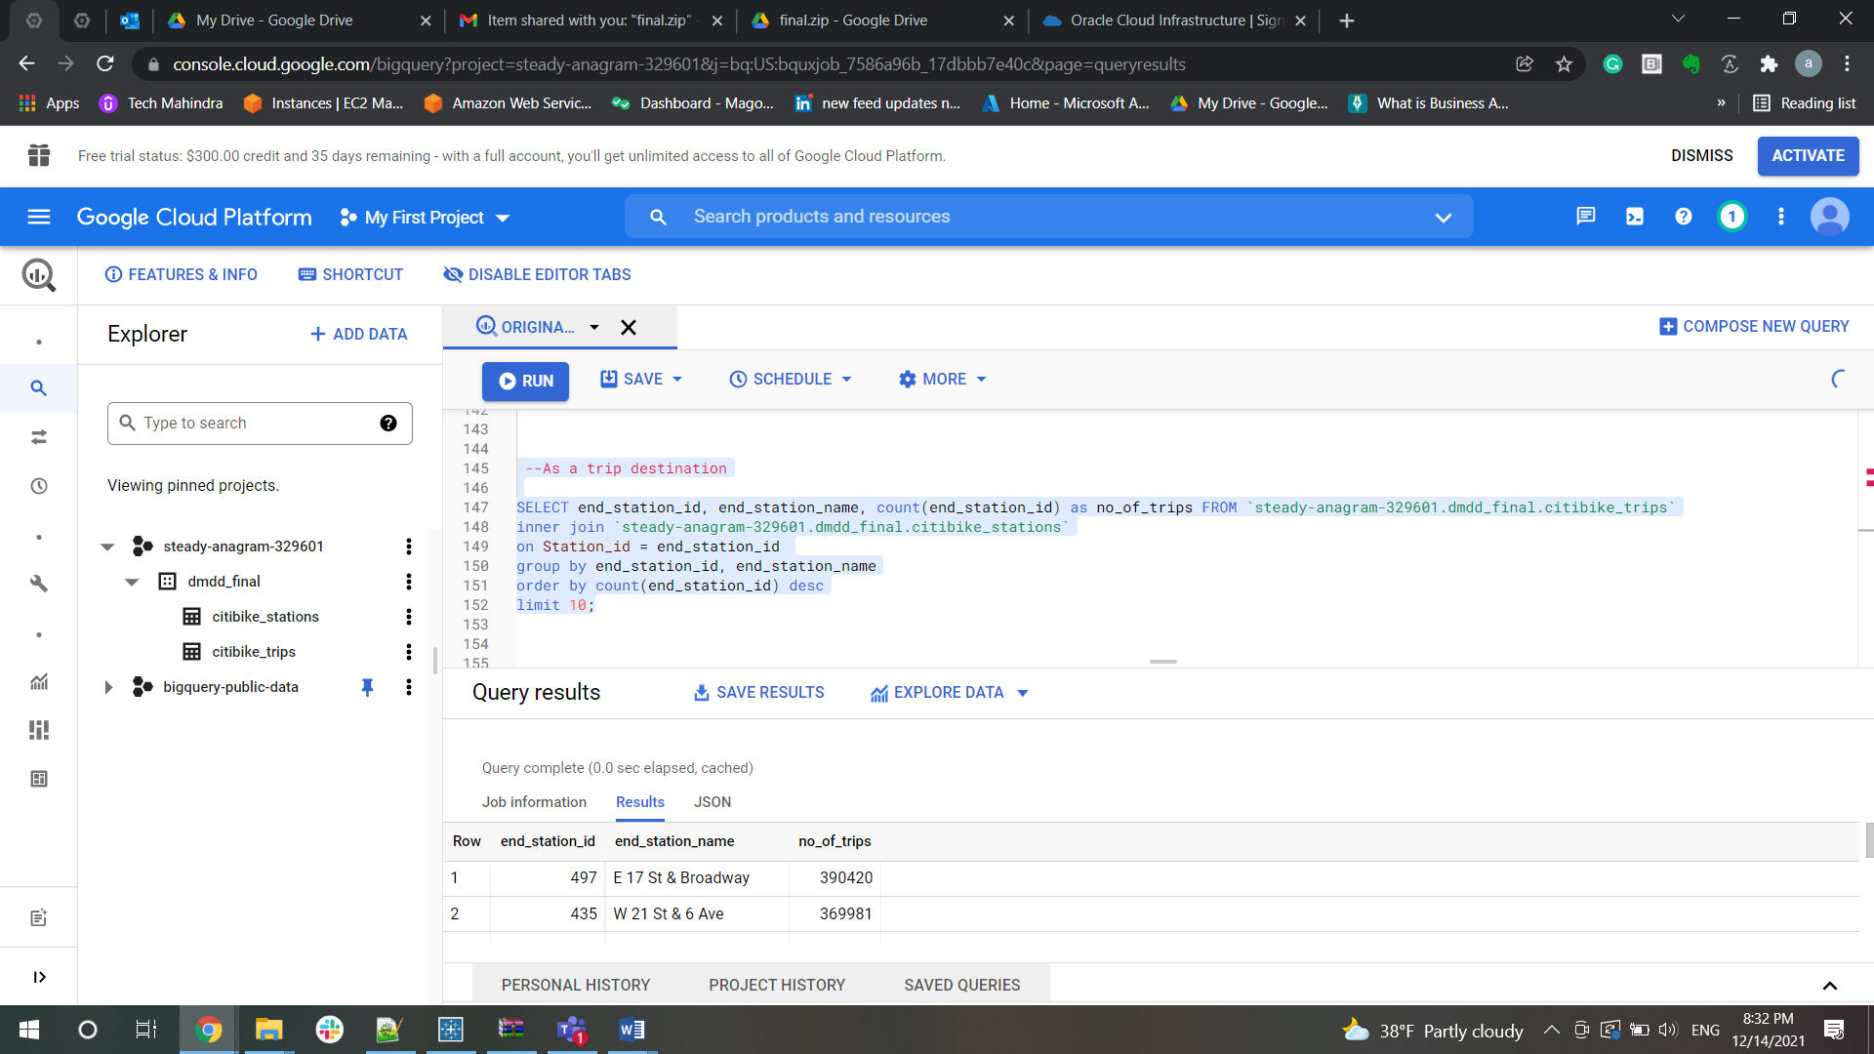

-- Overall, as ether a start and/or destination

SELECT station_id, count(station_id) as no_of_trips FROM `steady-anagram-329601.dmdd_final.citibike_stations`

inner join `steady-anagram-329601.dmdd_final.citibike_trips`

on Station_id = start_station_id

group by station_id

order by count(start_station_id + end_station_id) desc

limit 10;

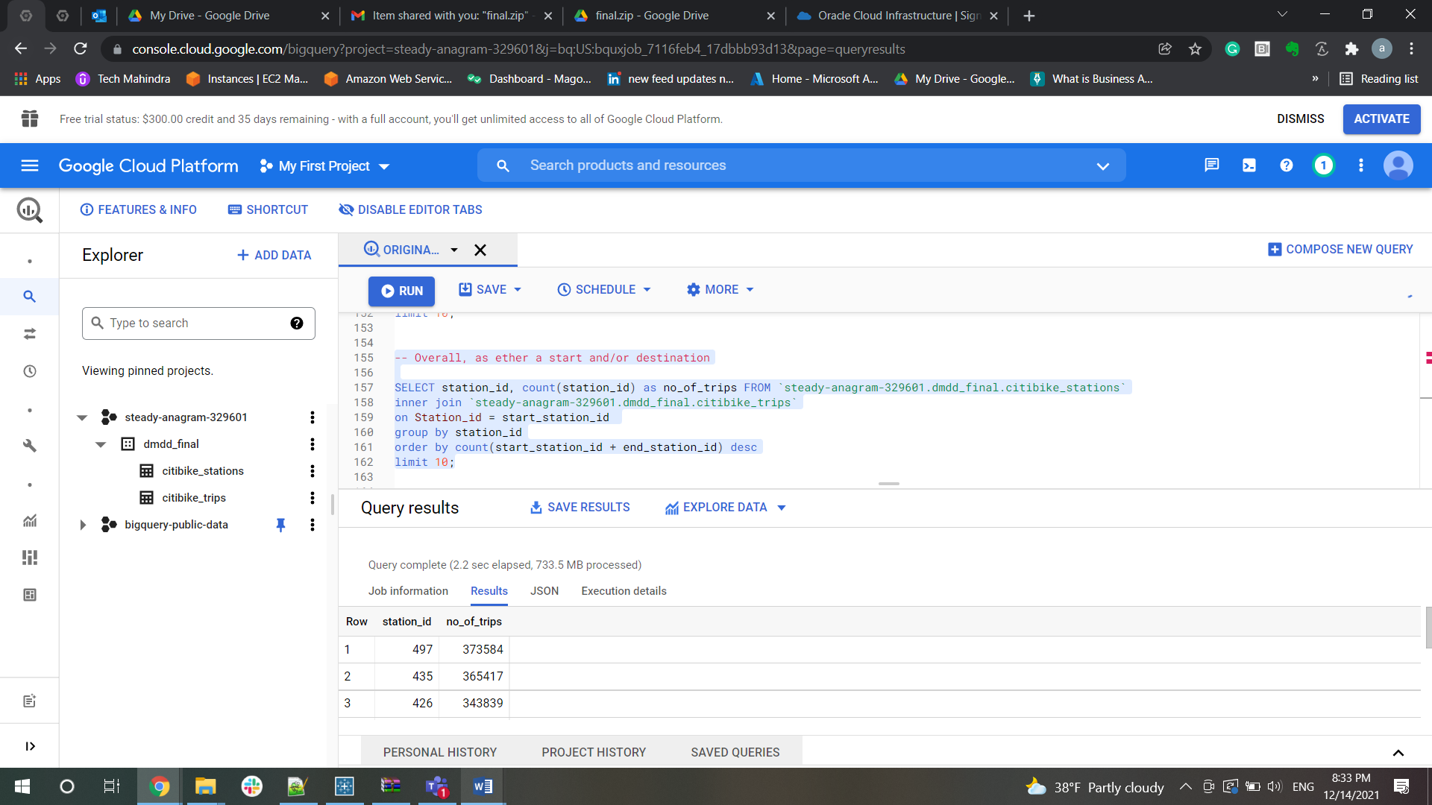

Determine the most popular routes (staring to end location)  
▪ Total number of trips

-- Determine the most popular routes (staring to end location)

-- Total number of trips

select count(*) as no_of_trips from `steady-anagram-329601.dmdd_final.citibike_trips`

 inner join `steady-anagram-329601.dmdd_final.citibike_stations`

 on Station_id = start_station_id

 and Station_id = end_station_id

 order by no_of_trips desc;

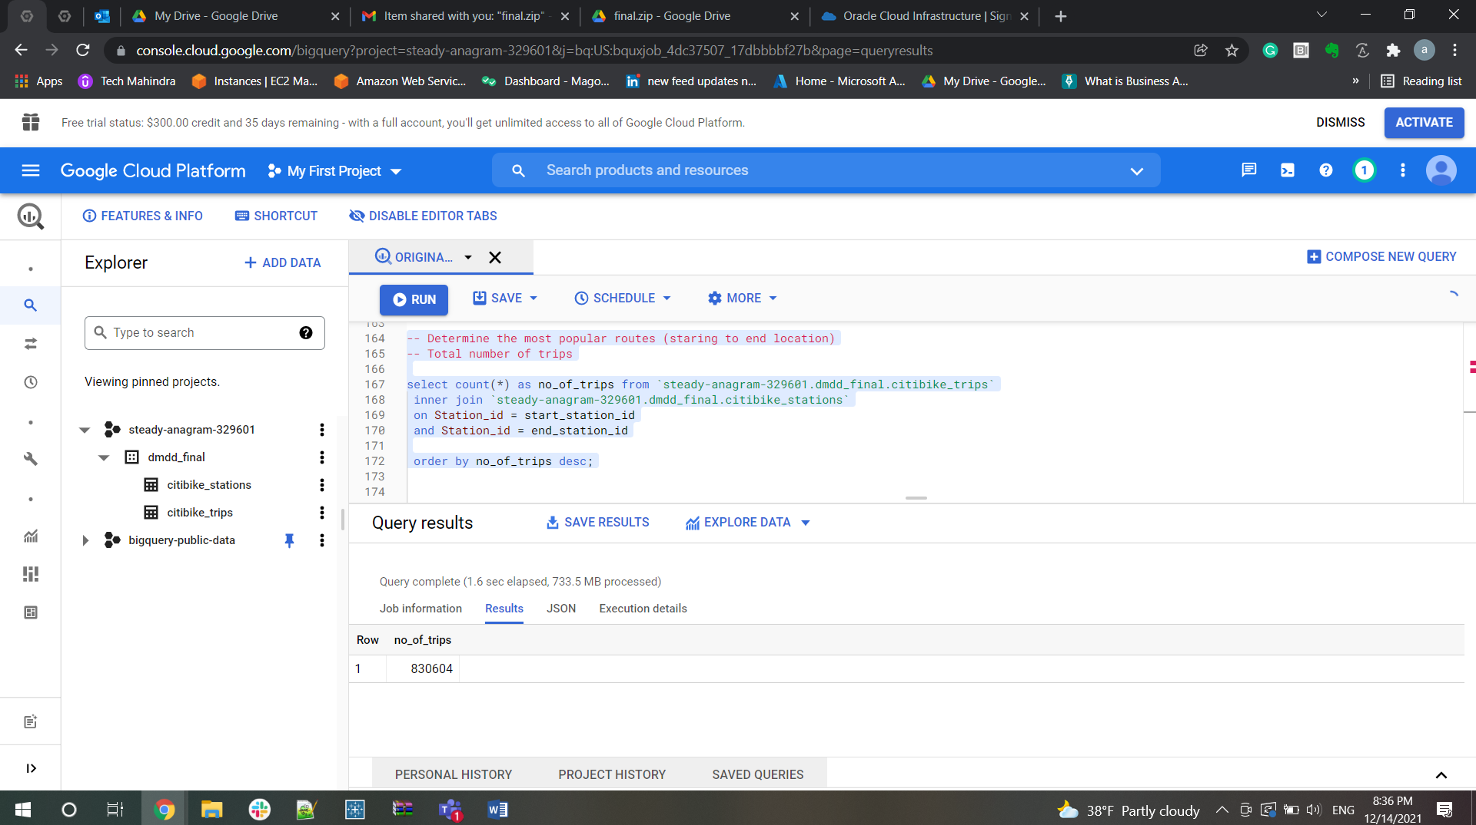

-- Total number of trips by subscriber and customer

select count(*) as no_of_trips, u.usertype from `steady-anagram-329601.dmdd_final.citibike_stations`

 inner join `steady-anagram-329601.dmdd_final.citibike_trips` as u

 on Station_id = start_station_id

 and Station_id = end_station_id

 where u.usertype in ('Subscriber','Customer')

 group by u.usertype

 order by no_of_trips desc,no_of_trips;

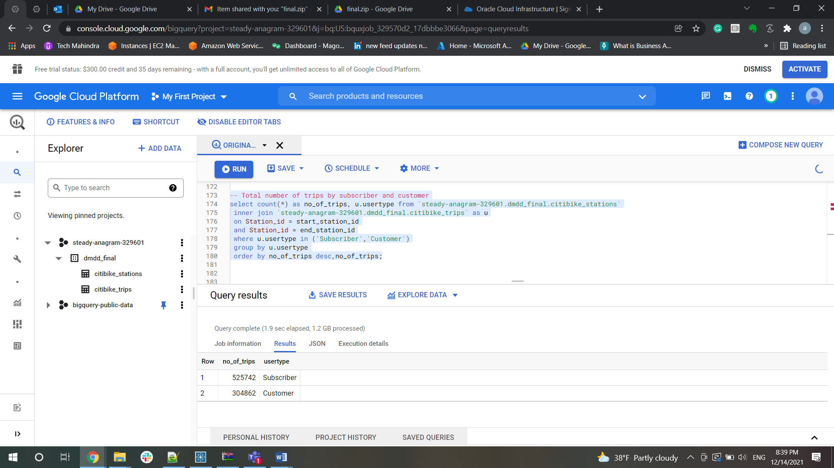

-- Month:

select count(*) as no_of_trips, u.usertype, EXTRACT(MONTH FROM starttime) as month  from `steady-anagram-329601.dmdd_final.citibike_stations`

 inner join `steady-anagram-329601.dmdd_final.citibike_trips` as u

 on Station_id = start_station_id

 and Station_id = end_station_id

 where u.usertype in ('Subscriber','Customer')

 group by u.usertype, u.starttime

 order by no_of_trips desc,no_of_trips;

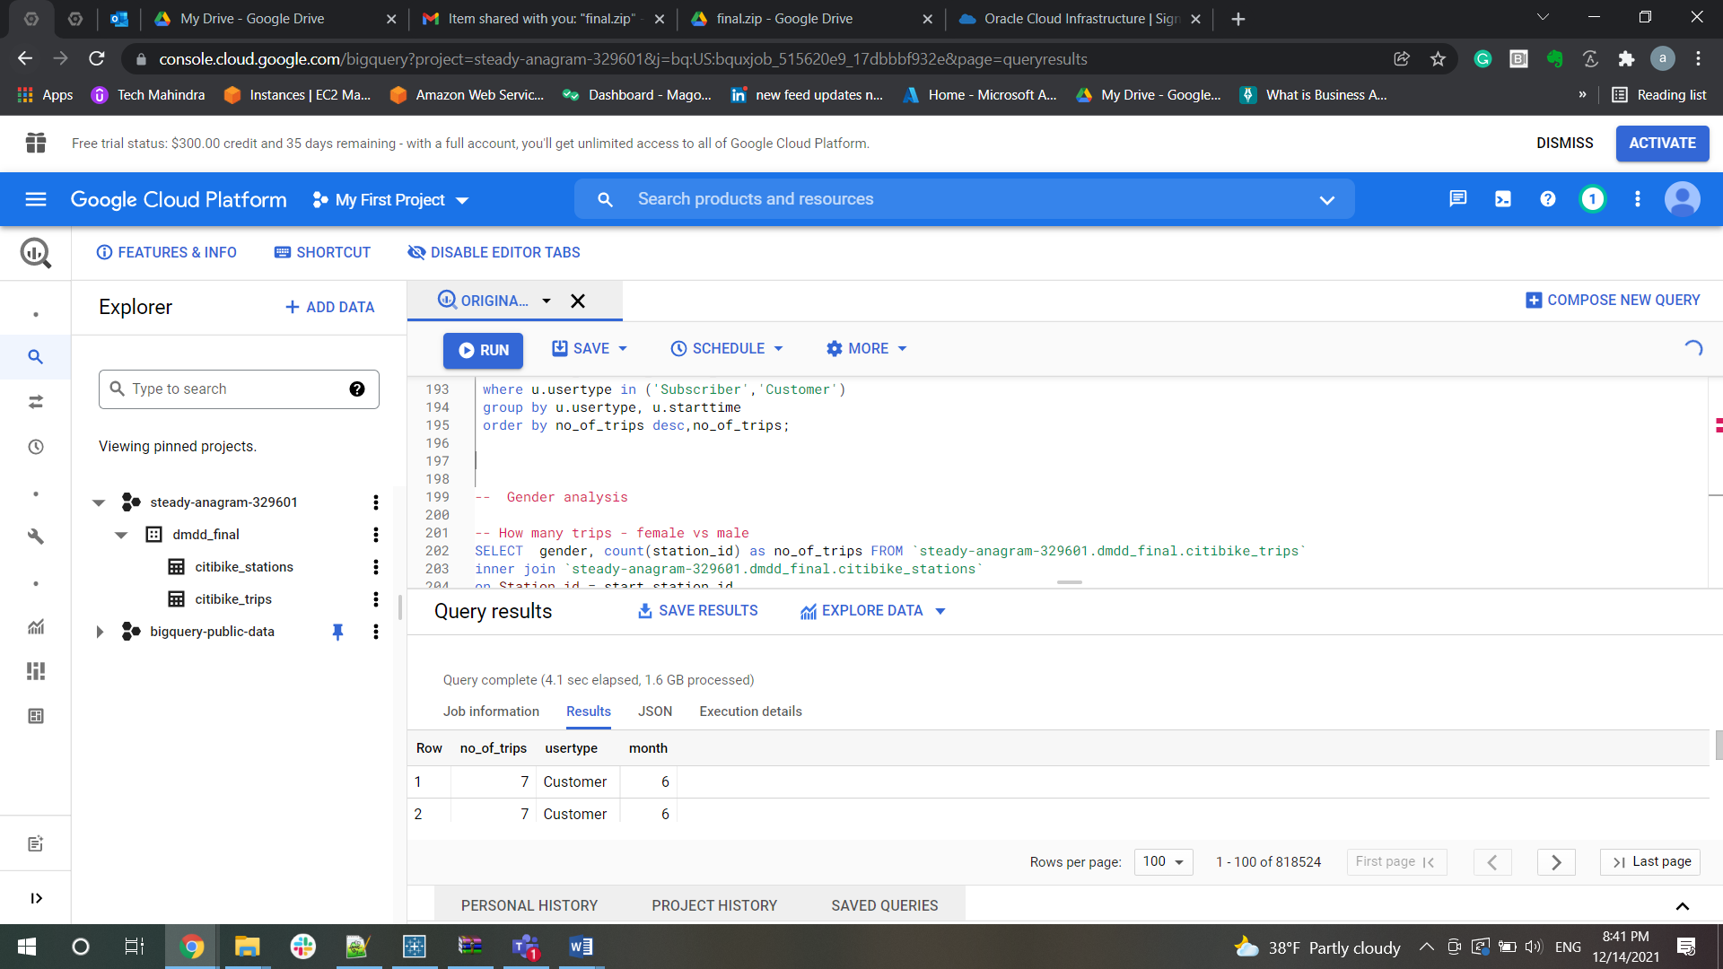

-- Time of the day:

select count(*) as no_of_trips, u.usertype, EXTRACT(time FROM starttime) as time  from `steady-anagram-329601.dmdd_final.citibike_stations`

 inner join `steady-anagram-329601.dmdd_final.citibike_trips` as u

 on Station_id = start_station_id

 and Station_id = end_station_id

 where u.usertype in ('Subscriber','Customer')

 group by u.usertype, u.starttime

 order by no_of_trips desc,no_of_trips;

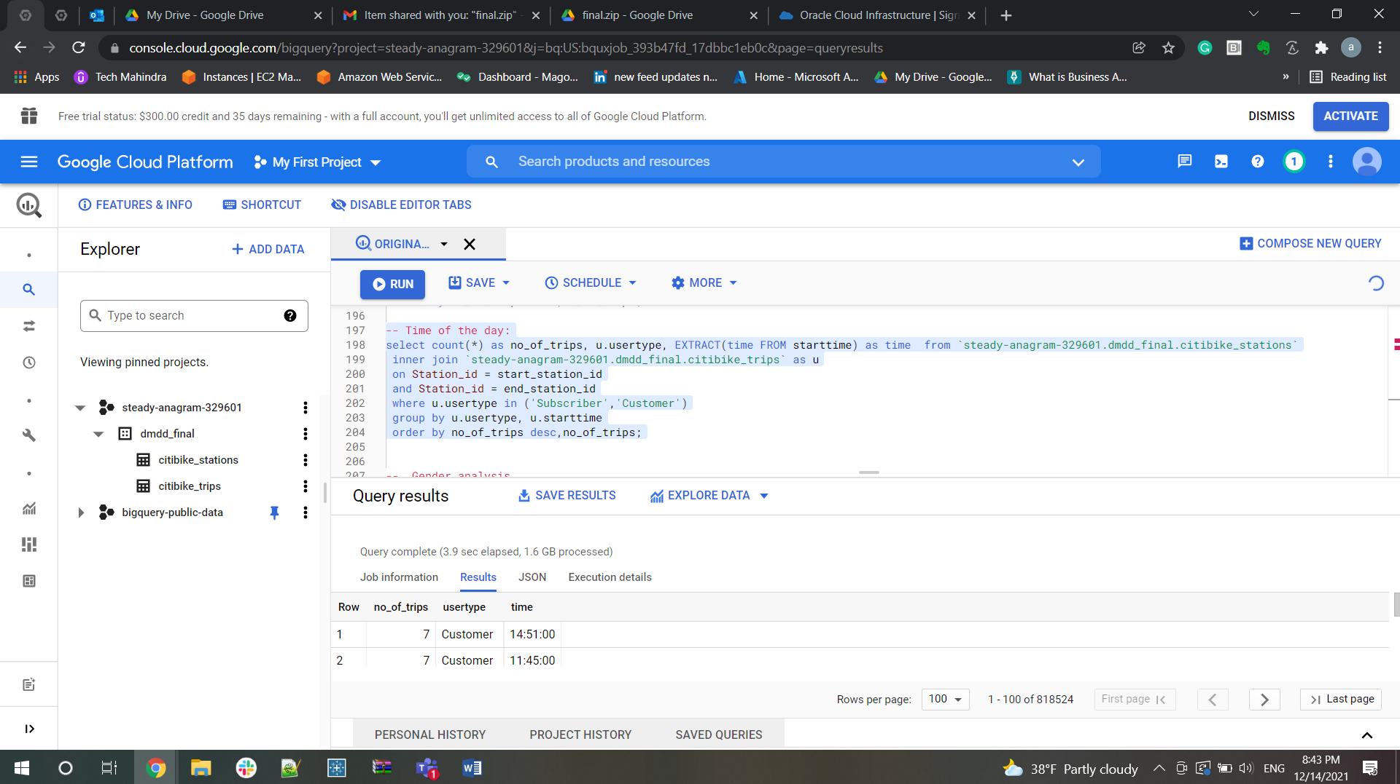

Weekday v/s weekends

SELECT count(bikeid) AS no_of_trips,start_station_name, end_station_name,

CASE WHEN

(EXTRACT (DAYOFWEEK FROM (starttime))IN (1,7)) THEN "WEEKEND"

ELSE "WEEKDAY"

END AS TYPE_OF_DAY

FROM `steady-anagram-329601.dmdd_final.citibike_trips`

where usertype != ""

group by start_station_name,end_station_name,TYPE_OF_DAY

order by count(bikeid) desc

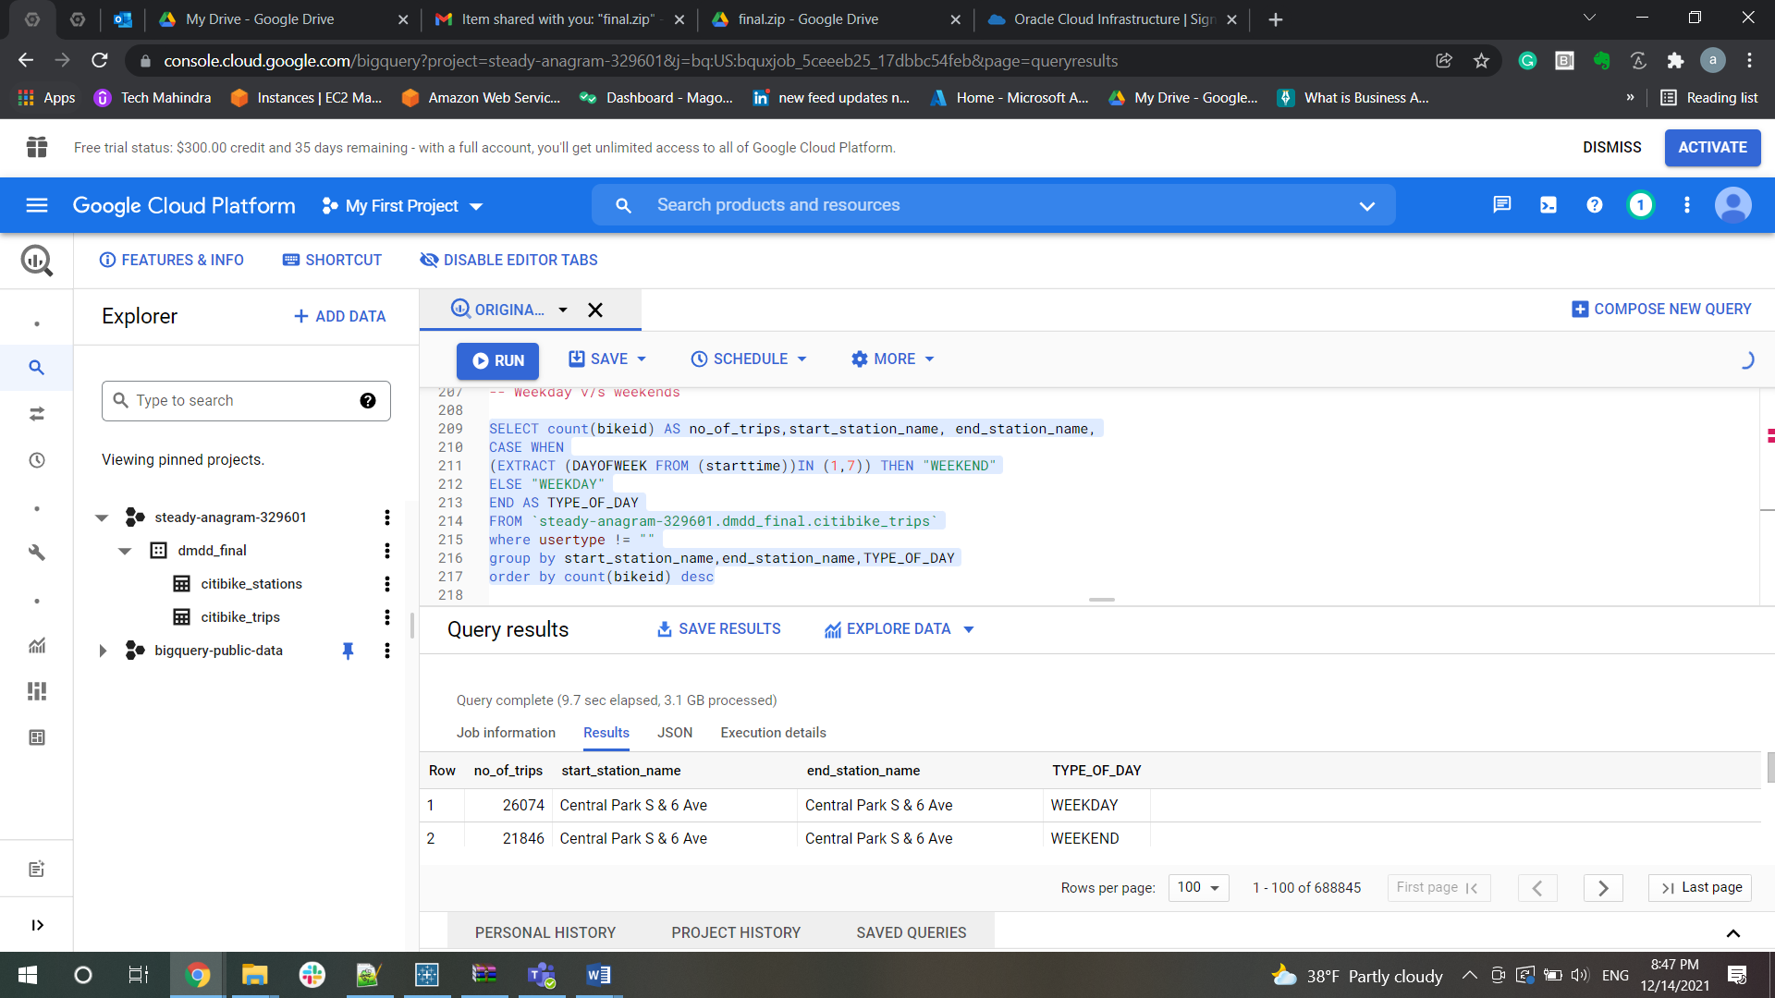

**Gender Analysis**

-- How many trips - female vs male

SELECT  gender, count(station_id) as no_of_trips FROM `steady-anagram-329601.dmdd_final.citibike_trips`

inner join `steady-anagram-329601.dmdd_final.citibike_stations`

on Station_id = start_station_id

group by gender

order by count(station_id) desc;

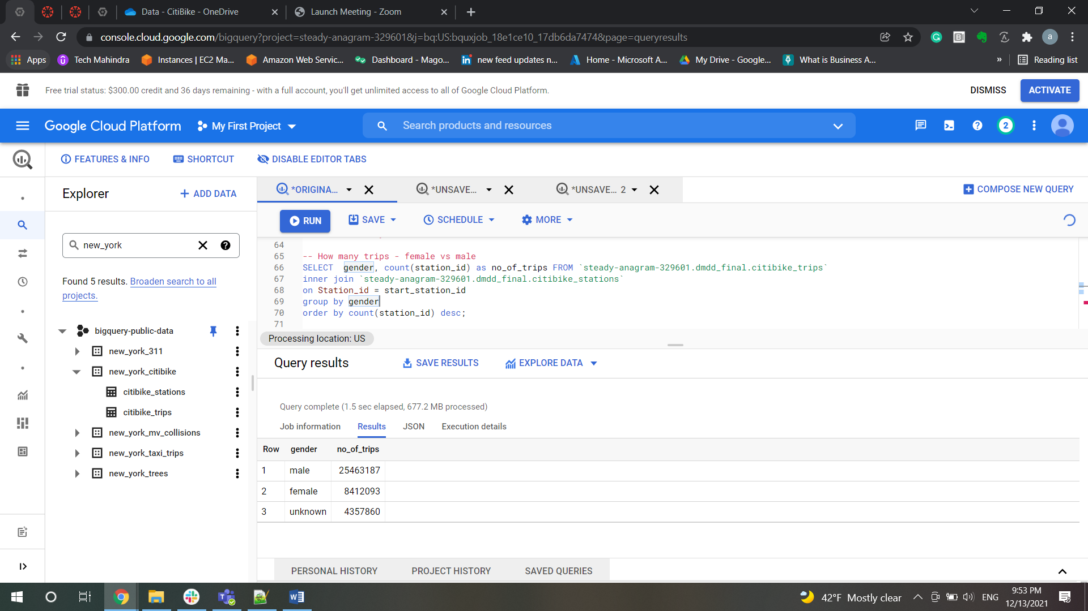

-- Average length of trip - female vs male

SELECT count(*) no_of_trips,gender, usertype

FROM `steady-anagram-329601.dmdd_final.citibike_trips`

group by gender,usertype

order by no_of_trips,usertype;

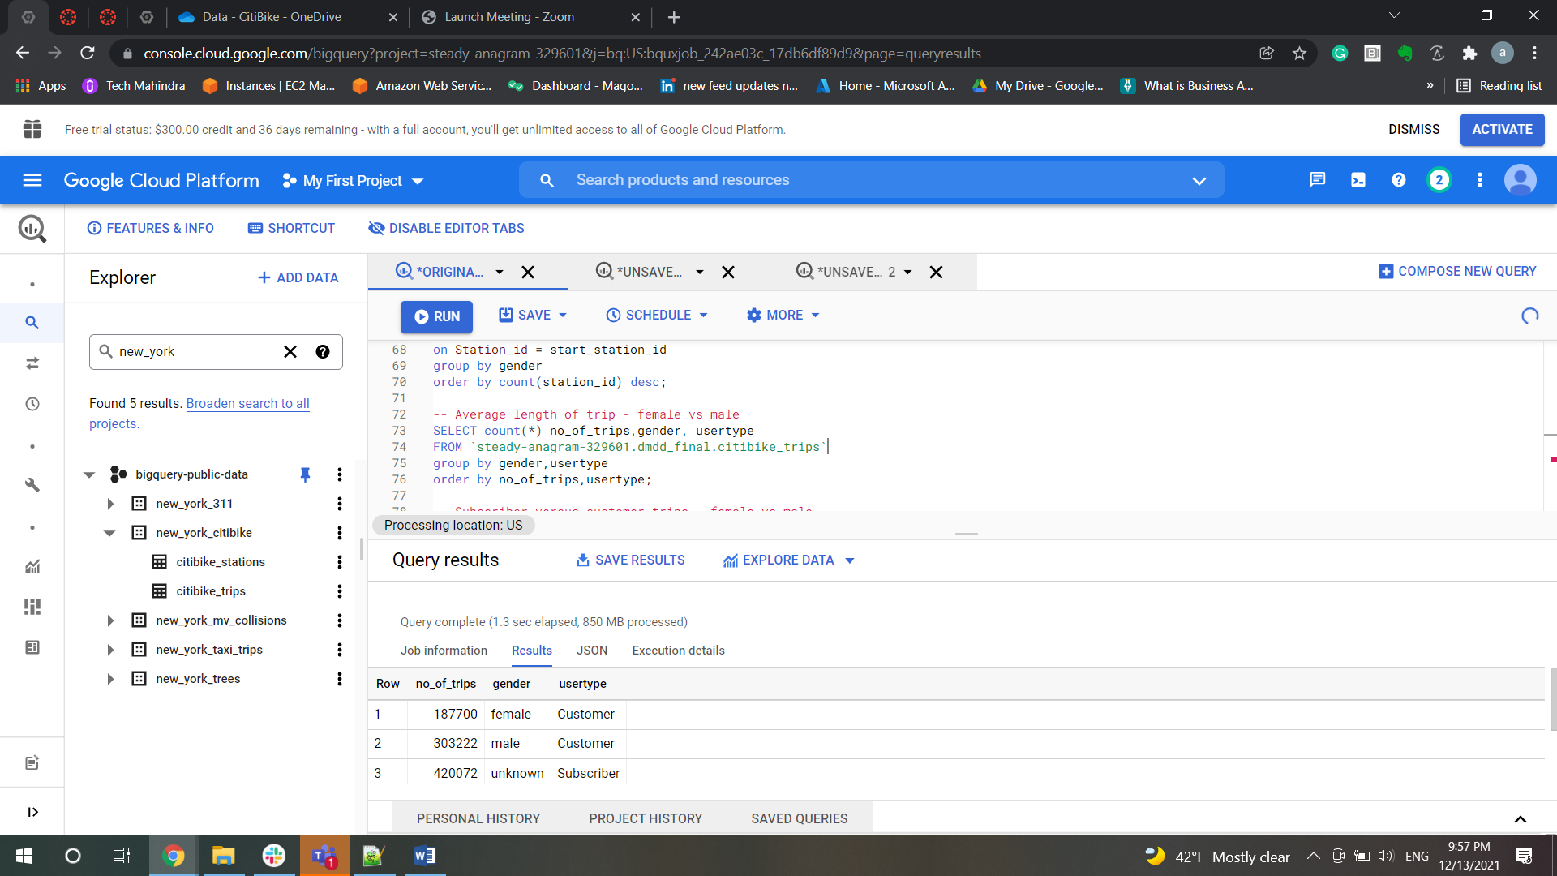

-- Subscriber versus customer trips - female vs male

SELECT gender, avg(tripduration / 60) as Average_Trip_Duration_in_Minutes FROM `steady-anagram-329601.dmdd_final.citibike_trips`

group by gender

order by avg(tripduration / 60) desc;

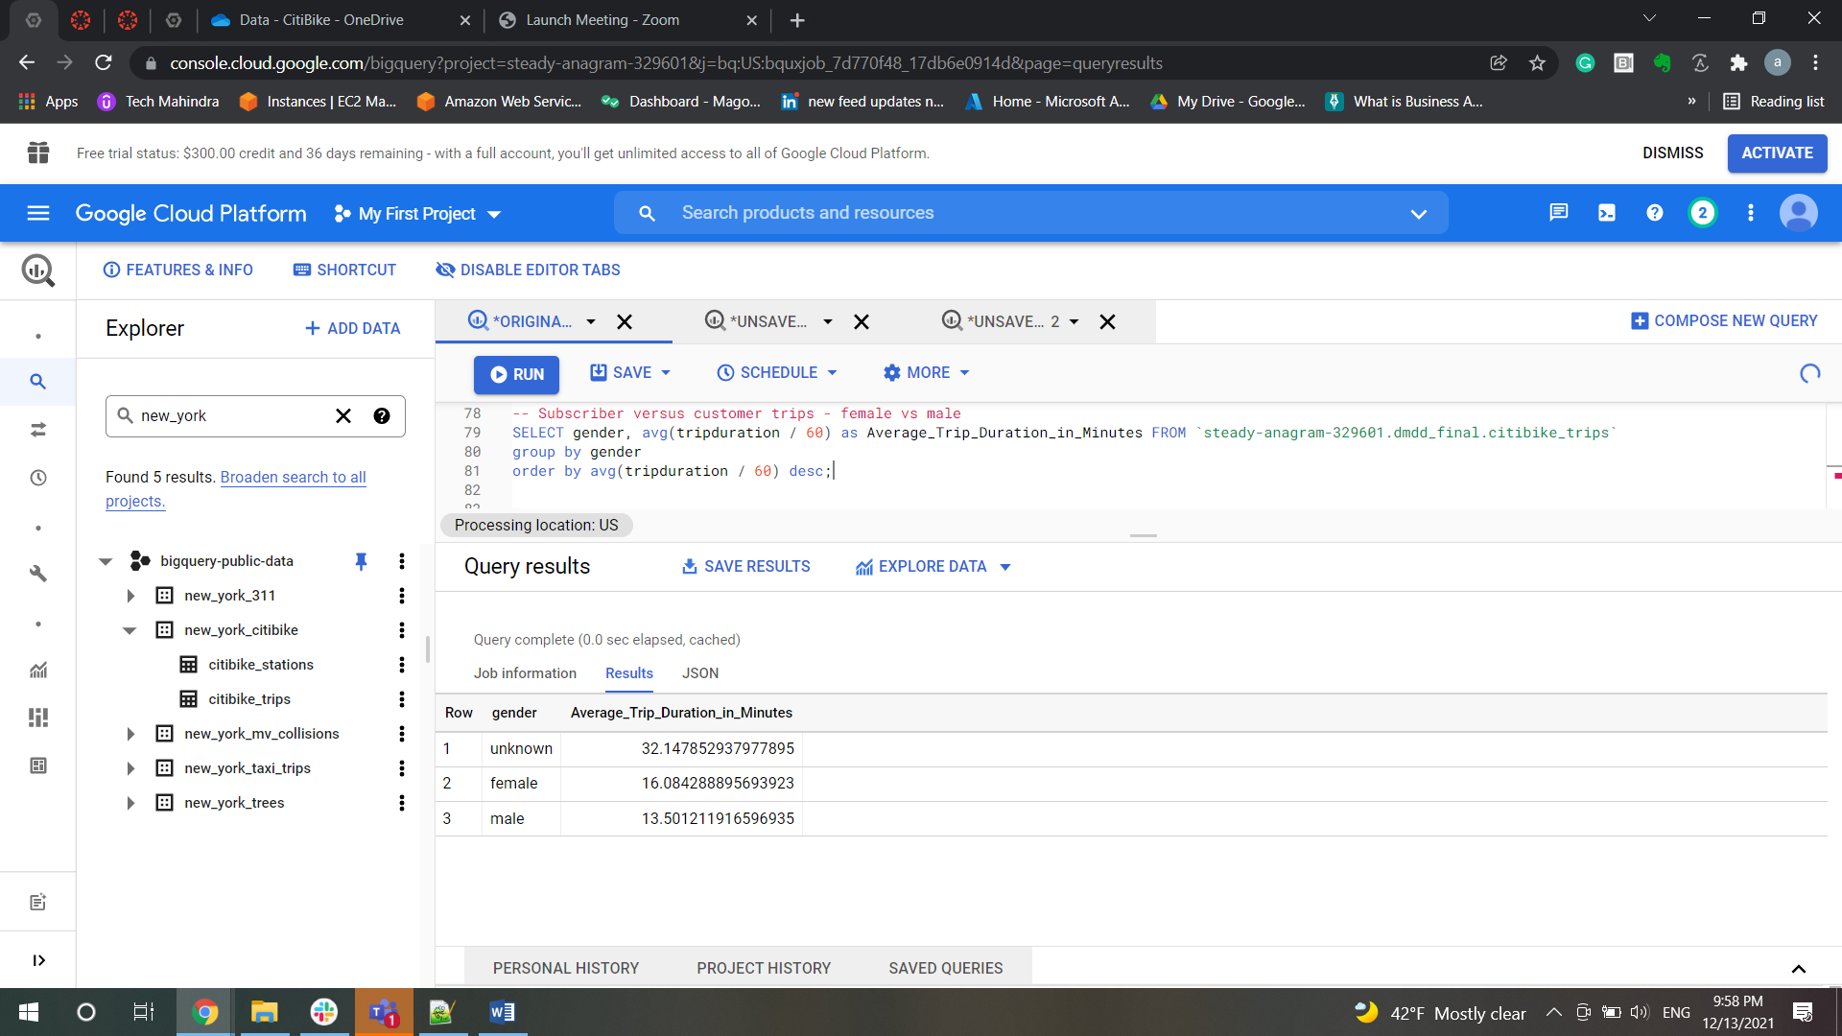

-- Any trends from 2014 to 2020 regarding above

SELECT  gender, count(station_id) as no_of_trips, EXTRACT(YEAR FROM starttime) AS year  FROM `steady-anagram-329601.dmdd_final.citibike_trips`

inner join `steady-anagram-329601.dmdd_final.citibike_stations`

on Station_id = start_station_id

group by  year, gender

order by count(station_id) desc;

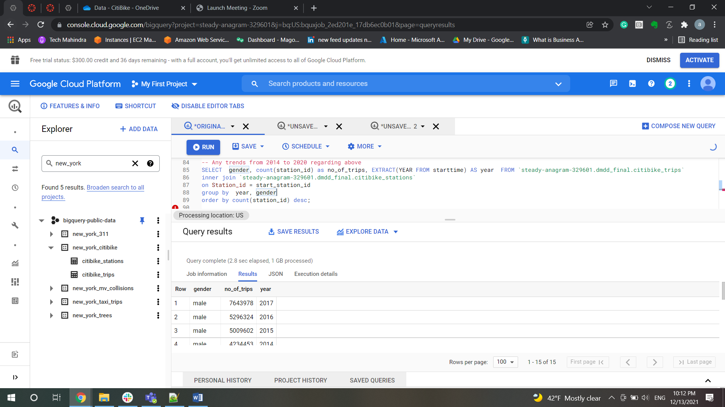

**Age**

-- Age analysis (note: age at the time of the ride i.e., age is year of bike trip vs birth year)

-- What are the number of trips per age

SELECT count(*) as no_of_trips,(ride_year-birth)as age,birth,

ride_year from (select distinct(birth_year) as birth,

extract (ISOYEAR from starttime) as ride_year from `steady-anagram-329601.dmdd_final.citibike_trips`

group by birth,ride_year) group by age,birth,ride_year

order by no_of_trips desc;

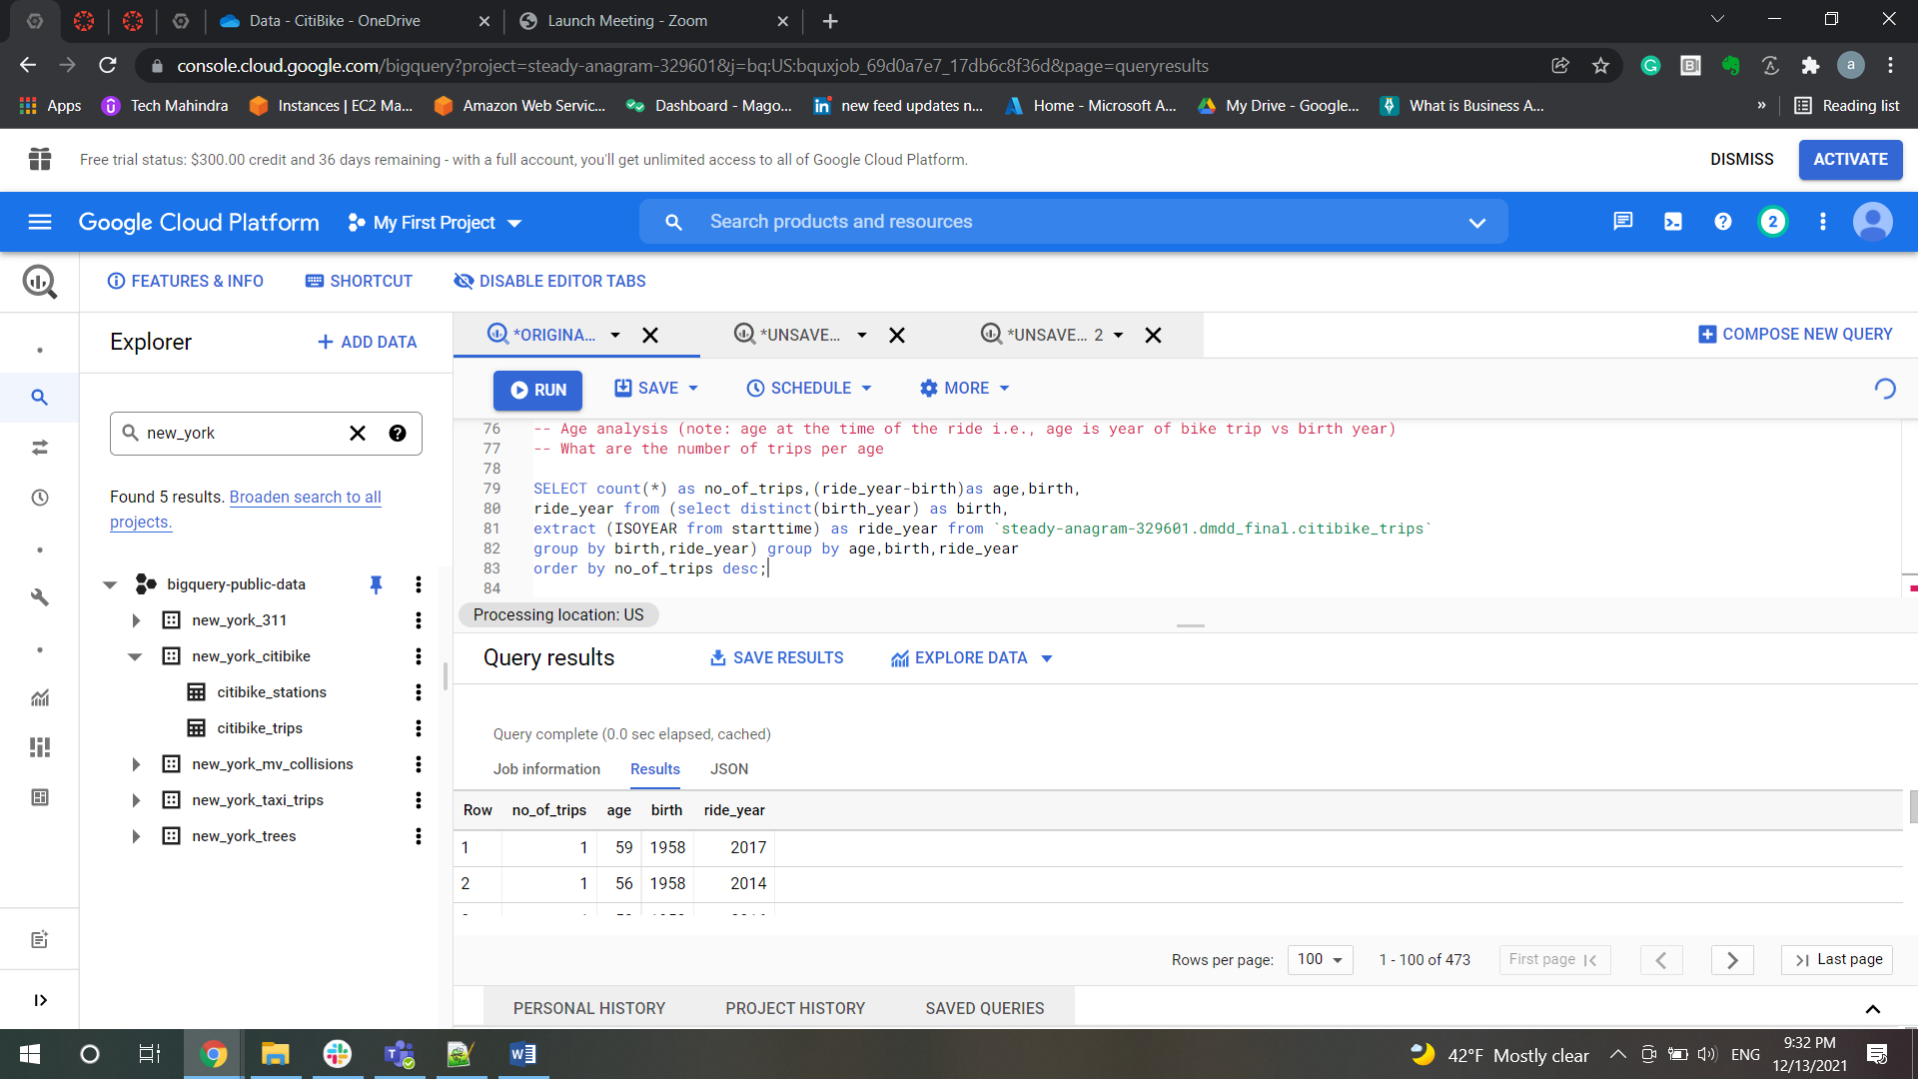

-- Average length of trip per age

SELECT avg(tripduration / 60) as Average_Trip ,(ride_year-birth)as age,birth,

ride_year from (select distinct(birth_year) as birth,

extract (ISOYEAR from starttime) as ride_year,tripduration from `steady-anagram-329601.dmdd_final.citibike_trips`

group by birth,ride_year,tripduration) group by age,birth,ride_year;

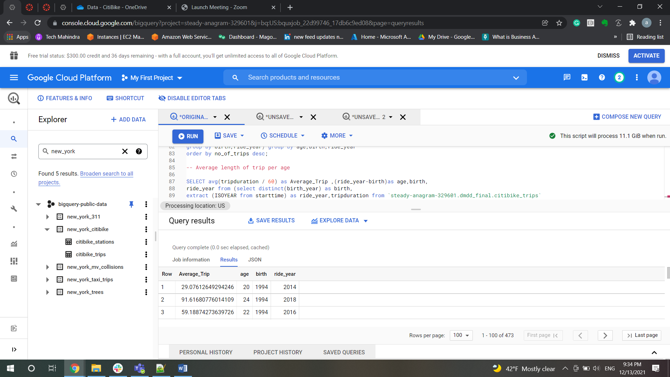

  -- Subscriber versus customer grouped together query

SELECT usertype,(ride_year-birth)as age,birth,

ride_year from

   (select distinct(birth_year) as birth,

   extract (ISOYEAR from starttime) as ride_year,usertype from `steady-anagram-329601.dmdd_final.citibike_trips`

   group by birth,ride_year,usertype)

group by usertype,age,birth,ride_year;

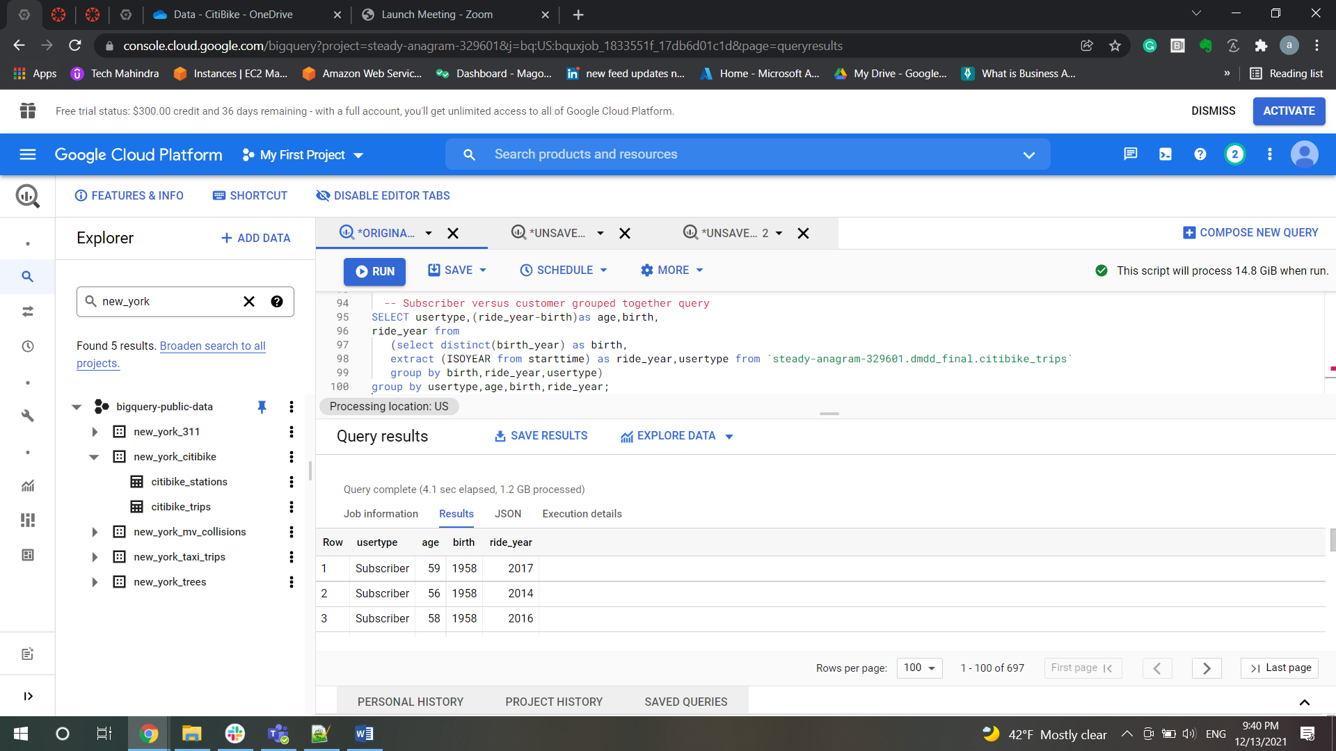

  --   -- Subscriber versus customer individual query

SELECT usertype,(ride_year-birth)as age,birth,

ride_year from

   (select distinct(birth_year) as birth,

   extract (ISOYEAR from starttime) as ride_year,usertype from `steady-anagram-329601.dmdd_final.citibike_trips`

   group by birth,ride_year,usertype)

   where usertype = "Customer"

group by usertype,age,birth,ride_year;

SELECT usertype,(ride_year-birth)as age,birth,

ride_year from

   (select distinct(birth_year) as birth,

   extract (ISOYEAR from starttime) as ride_year,usertype from `steady-anagram-329601.dmdd_final.citibike_trips`

   group by birth,ride_year,usertype)

   where usertype = "Subscriber"

group by usertype,age,birth,ride_year;

-- Any trends from 2014 to 2020 regarding above

SELECT count(*) as no_of_trips,(ride_year-birth)as age,birth,

ride_year from (select distinct(birth_year) as birth,

extract (ISOYEAR from starttime) as ride_year from `steady-anagram-329601.dmdd_final.citibike_trips`

group by birth,ride_year) group by age,birth,ride_year

order by no_of_trips desc;

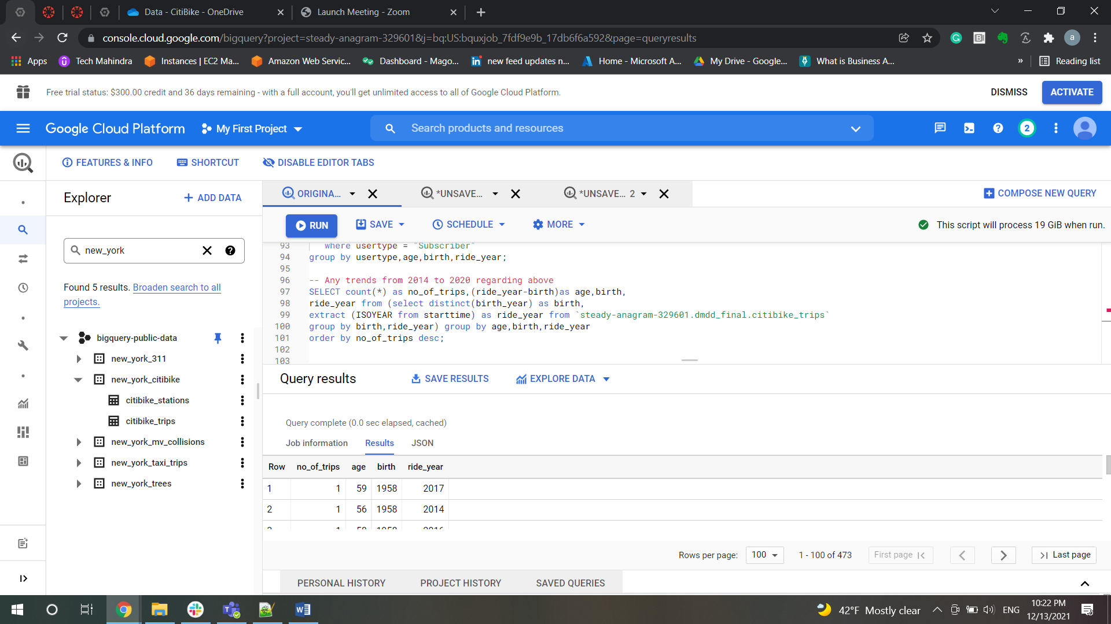

**BIKE ANALYSIS**

-- BIKE ANALYSIS

-- What are the top 5 bikes (bike id) for latest (full) year by

--Total trips

select distinct bikeid, count(*) as total_trips, EXTRACT(YEAR FROM starttime) as Year from `steady-anagram-329601.dmdd_final.citibike_trips`

group by bikeid, Year

order by Year desc, total_trips desc limit 5;

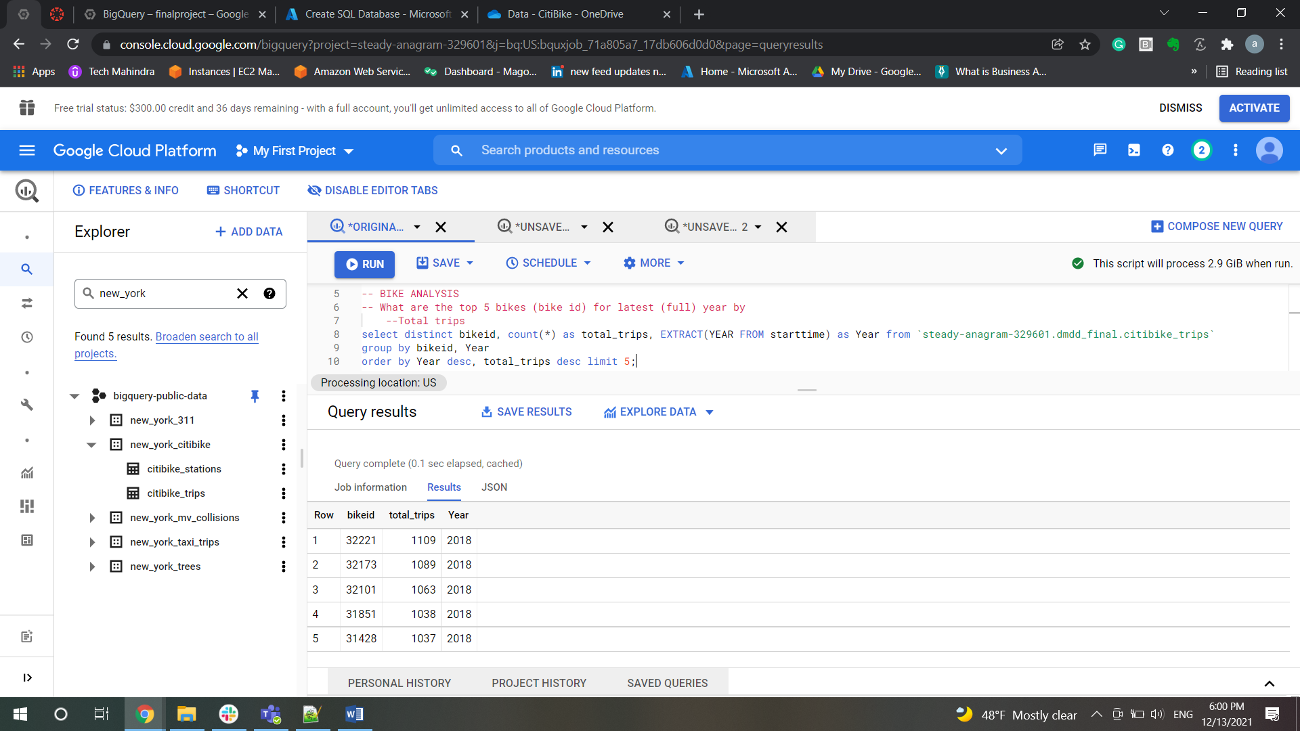

-- Total time

select distinct bikeid,(tripduration/60) as trip_duation_minutes, EXTRACT(YEAR FROM starttime) as Year from `steady-anagram-329601.dmdd_final.citibike_trips`

group by bikeid, Year, trip_duation_minutes

order by Year desc, trip_duation_minutes desc limit 5;

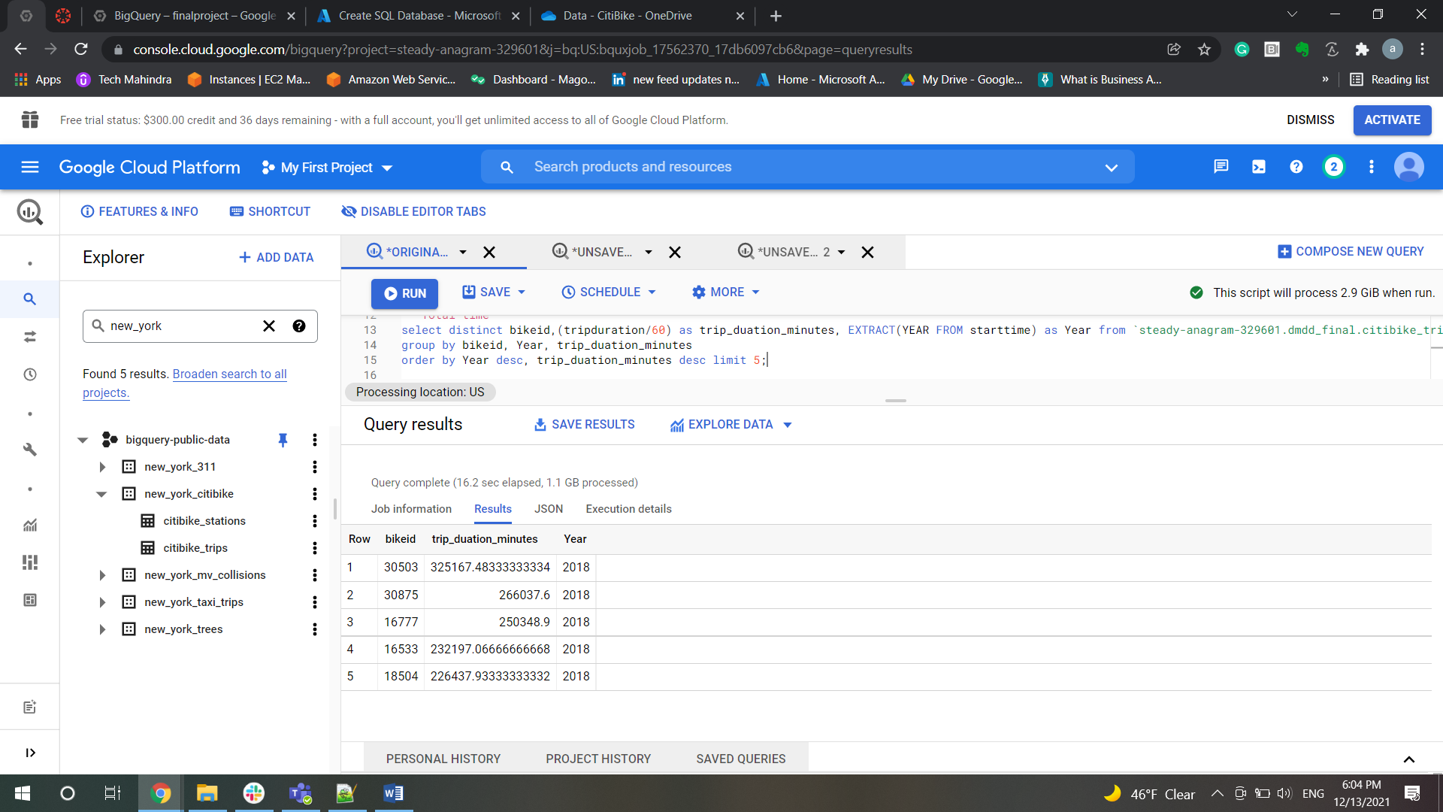

-- Average trip time

select distinct bikeid,avg(tripduration / 60) as Average_Trip_minutes, EXTRACT(YEAR FROM starttime) as Year from `steady-anagram-329601.dmdd_final.citibike_trips`

group by bikeid, Year

order by Year desc, Average_Trip_minutes desc limit 5;

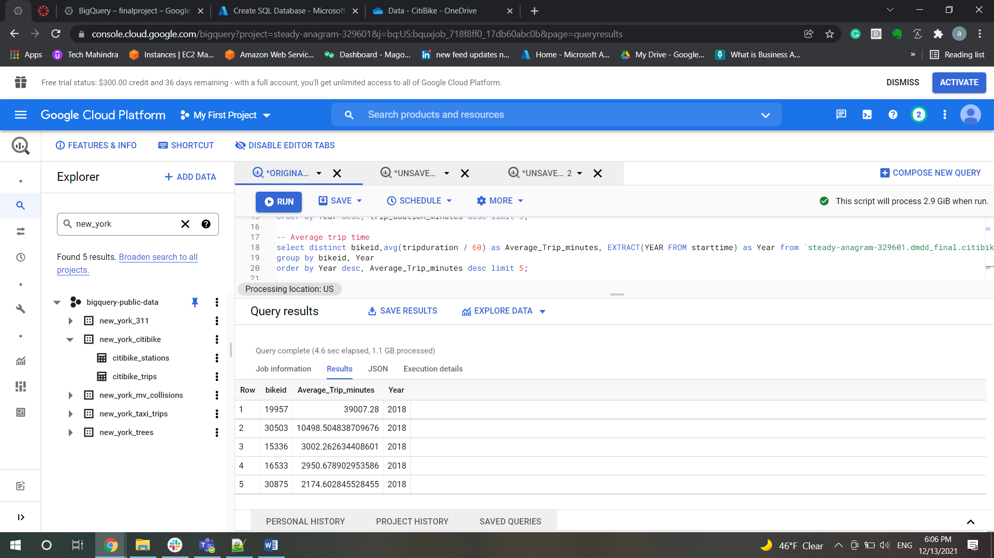

-- For top bike (by total trips) create a history for the latest (full) year

-- Bike id

select distinct bikeid, count(*) as total_trips, EXTRACT(YEAR FROM starttime) as Year from `steady-anagram-329601.dmdd_final.citibike_trips`

group by bikeid, Year

order by Year desc, total_trips desc ;

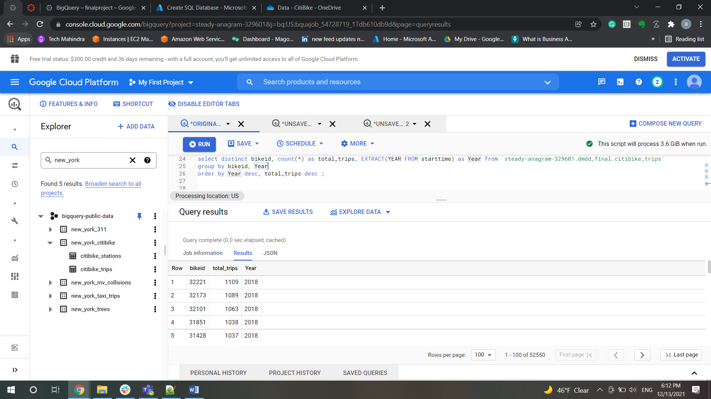

--  For top bike (by total trips) create a history for the latest (full) year

-- Bike id

select distinct bikeid, count(*) as total_trips, EXTRACT(YEAR FROM starttime) as Year from `steady-anagram-329601.dmdd_final.citibike_trips`

group by bikeid, Year

order by Year desc, total_trips desc,  bikeid desc ;

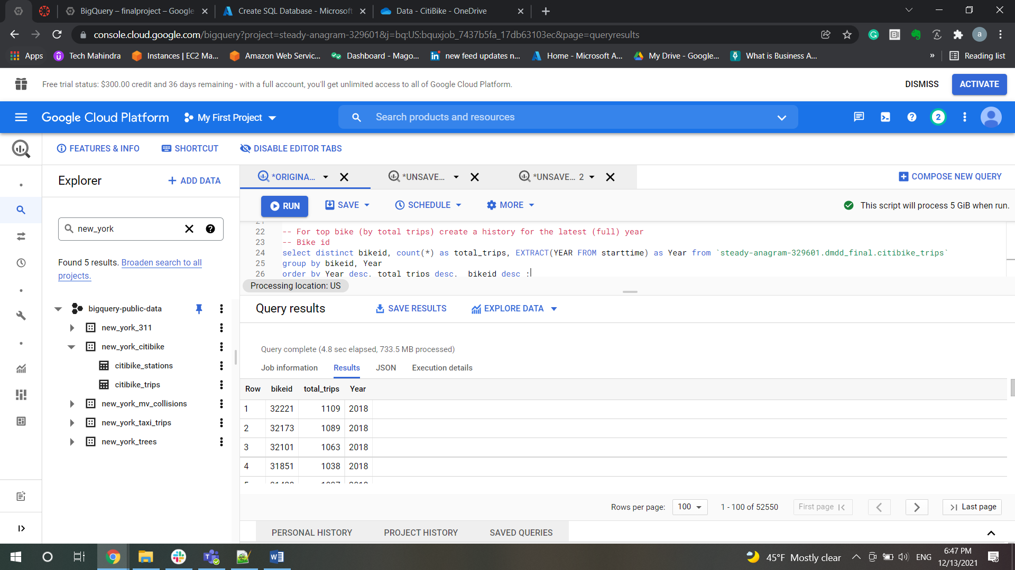

-- Route (state and end location)

select distinct(bikeid),count(*) as TotalTrips,EXTRACT(YEAR FROM starttime) AS year,start_station_id,end_station_id

FROM `steady-anagram-329601.dmdd_final.citibike_trips`

group by bikeid,year,start_station_id,end_station_id

order by year desc,TotalTrips desc;

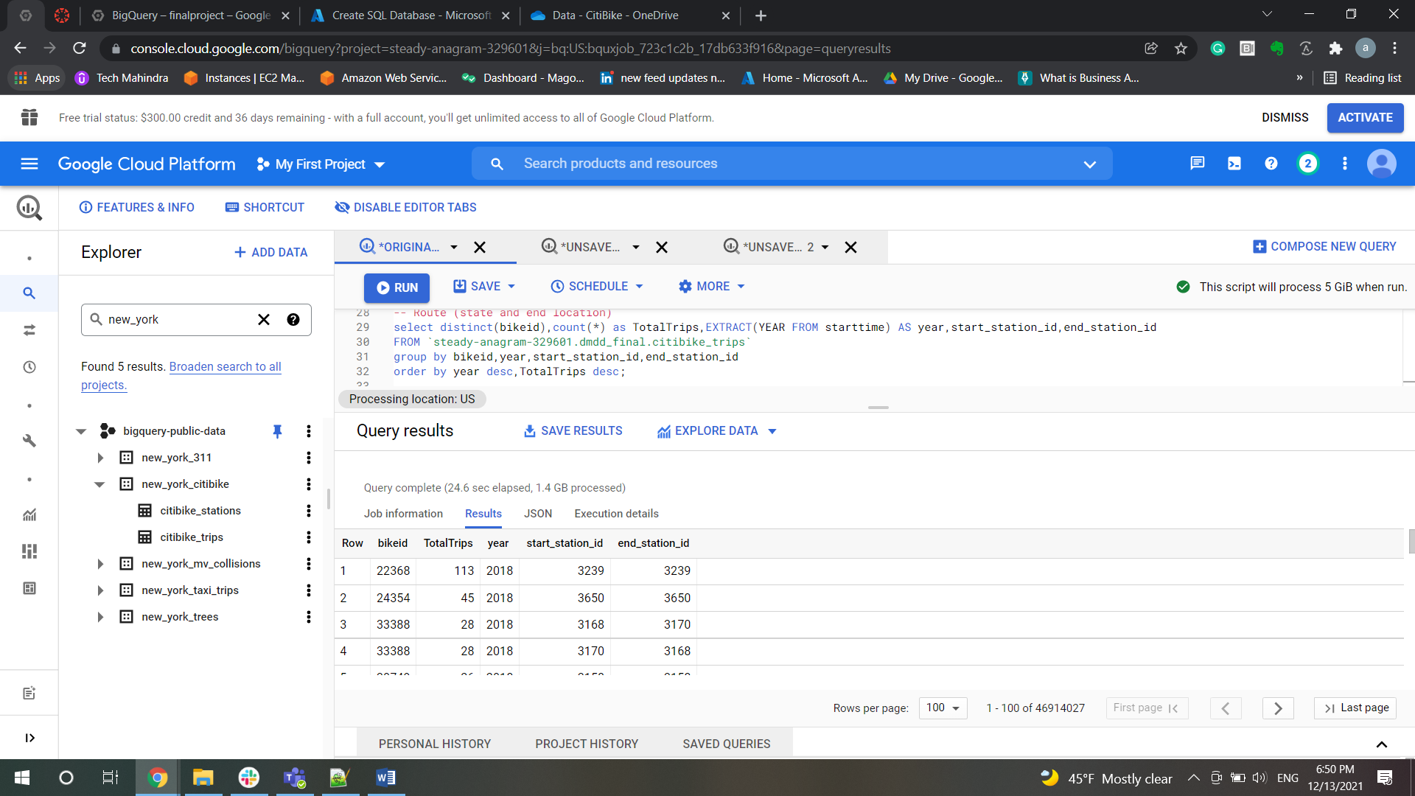

--Start time

select distinct(bikeid),count(*) as TotalTrips,EXTRACT(YEAR FROM starttime) AS year,starttime

FROM `steady-anagram-329601.dmdd_final.citibike_trips`

group by bikeid,year,starttime

order by year desc,starttime desc;

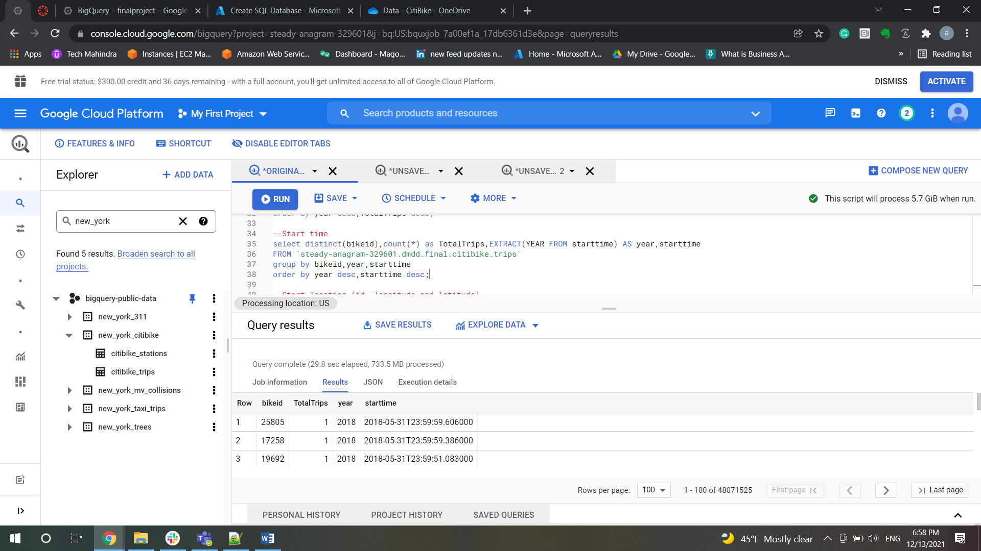

--Start location (id, longitude and latitude)

select distinct(bikeid),count(*) as TotalTrips,EXTRACT(YEAR FROM starttime) AS year,start_station_id, start_station_latitude, start_station_longitude

FROM `steady-anagram-329601.dmdd_final.citibike_trips`

group by bikeid,year,start_station_id, start_station_latitude, start_station_longitude

order by year desc, start_station_id desc , start_station_latitude desc, start_station_longitude desc;

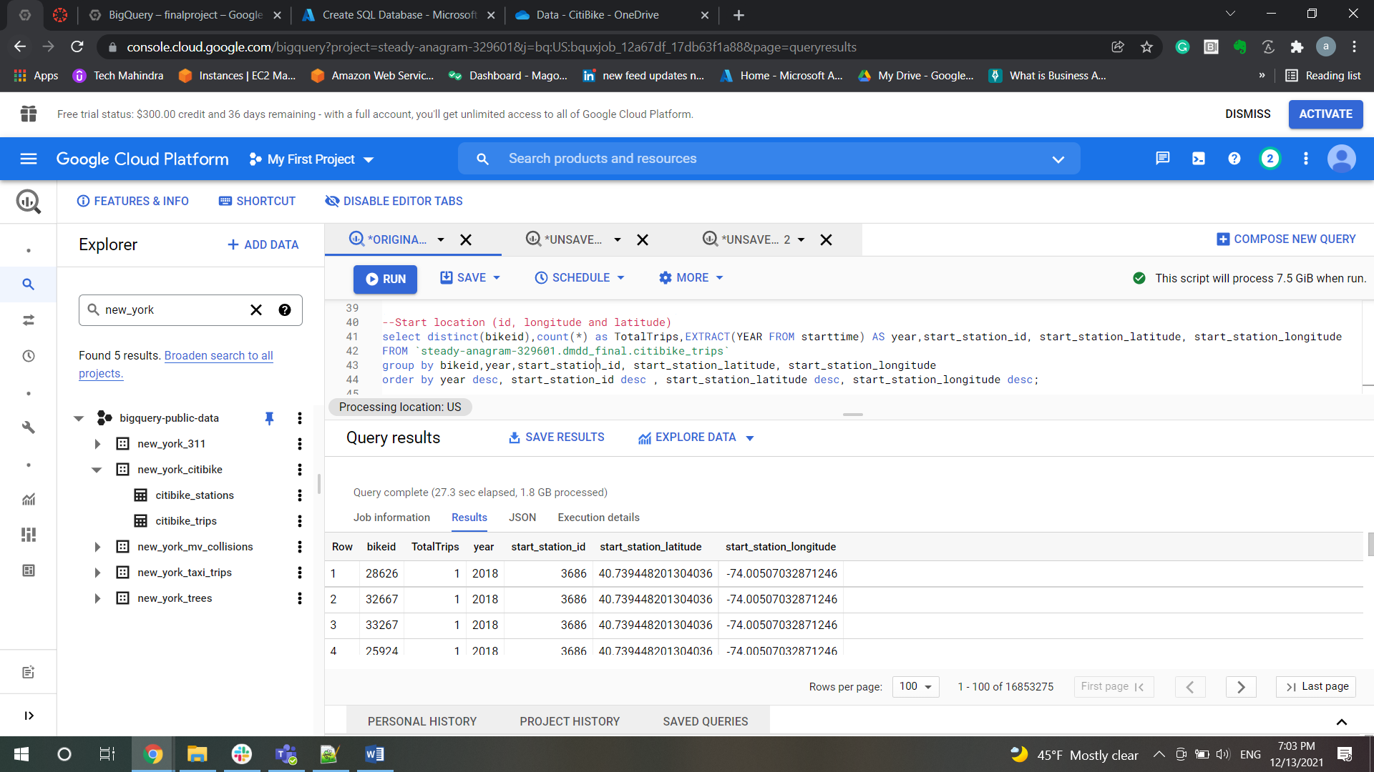

-- Duration

select distinct(bikeid),count(*) as TotalTrips,

(tripduration/60) TripDurationInMin,

EXTRACT(YEAR FROM starttime) AS year

FROM `steady-anagram-329601.dmdd_final.citibike_trips`

group by bikeid,year,TripDurationInMin

order by year desc,TripDurationInMin desc;

